**9Examen 2018 - Au fost ~35 intreabari. Majoritatea au fost schimbate cu exceptia: gtby1,5,10,16,17 + intrebarile din arhiva Mobile App Security 2017.7z ( se gaseste in folderul subiecte)**

**1. How Android applications manage the connections between interface elements and source code:**

1. using Layouts folder;
2. using R class;- Cosminel
3. using AppManifest.xml;
4. uninsg Drawable folder;

**2. Which one is not a security best practice when implementing Windows 8 applications?**

1. trust remote data;
2. don’t let the web access WinRT;
3. use the file picker instead of library capabilities;
4. minimize app capabilities;

**3. M-DRM -Mobile Digital Rights Management compliant with OMA - Open Mobile Alliance does NOT present the model:**

1. WAP Push;
2. Combined Delivery;
3. Forward Lock
4. Separated Delivery;

**4. Taking into account that IMEI = Interational Mobile Station Equipment Identity;**

**IMSI = interational Mobile Subscriber Identity; MSISDN = Mobile Subscriber Integrated Services Digital Network Number; SIM = Subscriber Identity Module; please select the correct answer:**

1. the mobile phone has as unique ID - the IMEI, and the SIM has as unique ID- the MSISDN
2. the mobile phone has as unique ID - the IMEI, and the SIM has as unique ID- the IMSI
3. the mobile phone has as unique ID - the IMSI
4. the SIM has as unique ID - the IMEI

**5. What happens with the Java coding files in the development process of an Android application:**

1. are converted to Java byte-code at runtime;
2. are converted to Dalvik byte-code at runtime;
3. are converted to Davlik byte-code at build time;
4. are converted to Java byte-code at build time;

**6. What permission must be defined in the AppManfest.xml file to allow Android applications to read SDcard:**

1. WRITE_EXTERNAL_STORAGE;
2. ACCESS_FINE_LOCATION;
3. READ_CONTACTS;
4. READ_FRAME_BUFFER;

**7. The migration from 2G to 3G technology involved changes in the following items within a mobile network operator for data communications**:

1. Only the mobile phone;
2. The mobile phone, BTS -Base Transceiver Station/NODE B, BSC - Base Station Controller/RNC - Radio Network Controller;
3. The mobile phone, BTS -Base Transceiver Station/NODE B, BSC - Base Station Controller/RNC - Radio Network Controller, SGSN - Serving GPRS Support Node;
4. The mobile phone, BTS -Base Transceiver Station/NODE B, BSC - Base Station Controller/RNC - Radio Network Controller, SGSN - Serving GPRS Support Node, GGSN - Gateway GPRS Support Node where GPRS = General Packet Radio Service;

**8. Which of the followings is NOT a design principle of Windows 8 applications?**

1. Apps do not put the customer in control;
2. apps provide value to the customer;
3. apps behave predictably;
4. apps are not appropriate for a local audience, but for a global one;

**9. For Blackberry devices a common development approach is:**

1. to develop using C# Common Language Runtime;
2. to develop only JME -Java MicroEdition MIDlets;
3. to combime development runtimes: Native(Qt/QML), JME - Proprietary JVM (CLDC, MIDlets, RIMIlets)+ HTML5
4. to develop only in MDS - Mobile Data Service Runtime;q

**10. Which are the main advantages of the fact that Android applications are running in a custom clean-room implementation of a virtual machine:**

1. application portability, application reliability, optimized file format;
2. application portability, optimized file format, runtime consistency;
3. application portability, application reliability, runtime consistency;
4. optimized file format, application reliability, runtime concistency;

**11. In the following JME source code please choose the correct answer:**

import javax.microedition.lcdui.*;

import javax,microedition.midlet.*.

public class HelloWorldApp extends MIDlet implements CommandListener{

private Form mMainForm;

public HelloWorldApp(){

mMainForm= new Form("HelloMIDlet");

mMainForm.append(new StringItem(null," Hello, Test!");

mMainForm.addCommand(new COmmand("Exit", Command.EXIT,0));

mMainForm.setCommandListener(this);

}

public void startApp(){

Display.getDisplay(this).setCurrnet(mMainForm);

}

public void pauseApp() {}

public void destroyApp(boolean unconditional) {}

public void commandAction(Command c, Displayable s){

notifyDestroyed();

}

}

1. the application is not a MIDlet;
2. the constructor HelloWorldApp is called when the application is closing;
3. the constructor HelloWorldApp is called when the application is starting;
4. the field mMainForm represents the application Context;

**12. The correct answer in terms of GSM security for SRES - Signed Response is :**

1. The SRES is obtained using A8 algorithm and initial key Ki, by signing the random number RAND generated by the NSS - Network SubSystem;
2. The SRES is obtained using A algorithm and initial key Ki, by signing the random number RAND generated by the NSS - Network SubSystem;
3. The SRES is obtained using A5 and A8 algorithm and initial key Ki, by signing the random number RAND generated by the NSS - Network SubSystem;
4. The SRES is obtained using A3 algorithm and initial key Ki, by signing the random number RAND generated by the NSS - Network SubSystem;

**13.In the manifest fie for a Windows 8 application, the developer does not need to declare**

1. Title customization;
2. application identity
3. OS specific dependencies
4. Application architecture

**14. JTWI - Java Technlogy for Wireless Industry umbrella contains (JCP - Java Community Process, JSR - Java Specification Req):**

1. JSR 30 & JSR 139 ( CLDC - Conected Limited Device Configuration) + JSR 37 &118( MIDP- Mobile Information Device Profile) + JSR 120( Wireless Messaging) + JSR 135 (Mobile Media API) + JSR 829 (Bluetooth &OBEX);
2. JSR 30 & JSR 139 ( CLDC - Conected Limited Device Configuration) + JSR 37 &118( MIDP- Mobile Information Device Profile) + JSR 120( Wireless Messaging) + JSR 135 (Mobile Media API);
3. JSR 30 & JSR 139 ( CLDC - Conected Limited Device Configuration) + JSR 37 &118( MIDP- Mobile Information Device Profile) + JSR 120( Wireless Messaging) + JSR 135 (Mobile Media API) + JSR 829 (Bluetooth &OBEX) + JSR 229 (Paymeny);
4. JSR 30 & JSR 139 ( CLDC - Conected Limited Device Configuration) + JSR 37 &118( MIDP- Mobile Information Device Profile) + JSR 120( Wireless Messaging) + JSR 135 (Mobile Media API) + JSR 829 (Bluetooth &OBEX) + JSR 172 (Web Services);

**15.The correct answer in terms of GSM security is:**

1. The mobile phone encrypts/decrypts the voice communications between the device and BSS – Base Station Subsystem using A5 algorithm
2. The mobile phone is authenticating to the mobile network operator using A5 algorithm
3. The SIM is authenticating to the mobile network operator using A5 algorithm
4. The mobile phone is authenticating to the mobile network operator using A8 algorithm

**16. Which of the following services is used to ensure local data persistency:**

1. Content Manager;
2. MySQL Service;
3. Oracle Intermedia;
4. SQL Lite;

**17. Please specify what answer is NOT a mobile operating system for the smart-phones:**

1. Blackberry OS;
2. Google Android;
3. Apple iOS;
4. JME - Java Micro Edition;

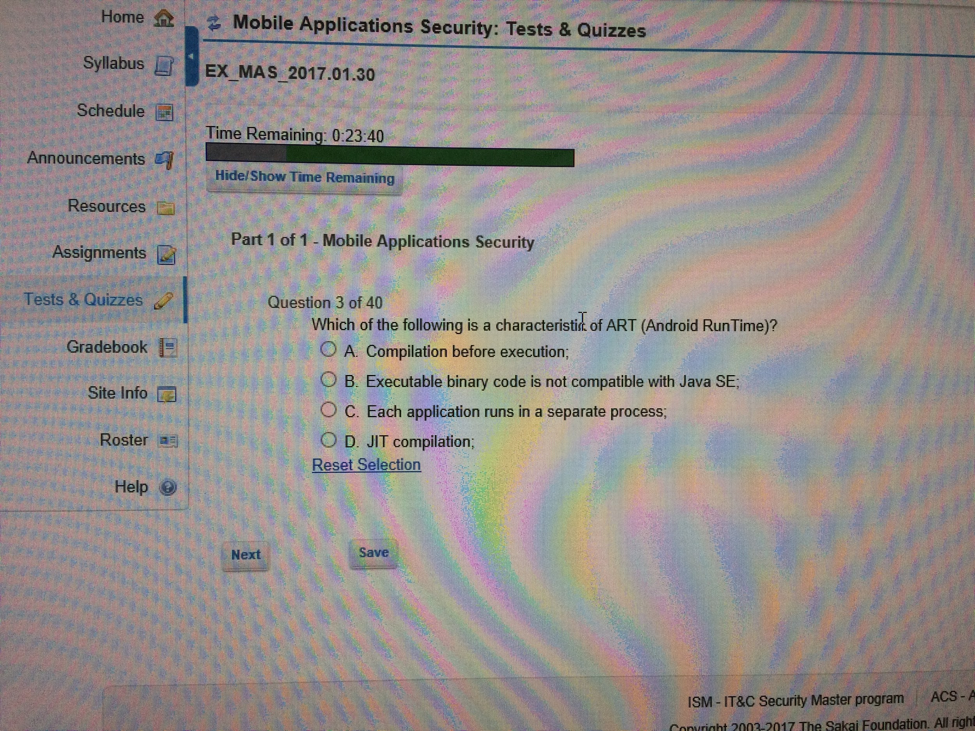

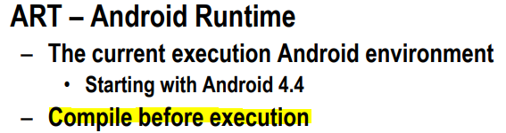

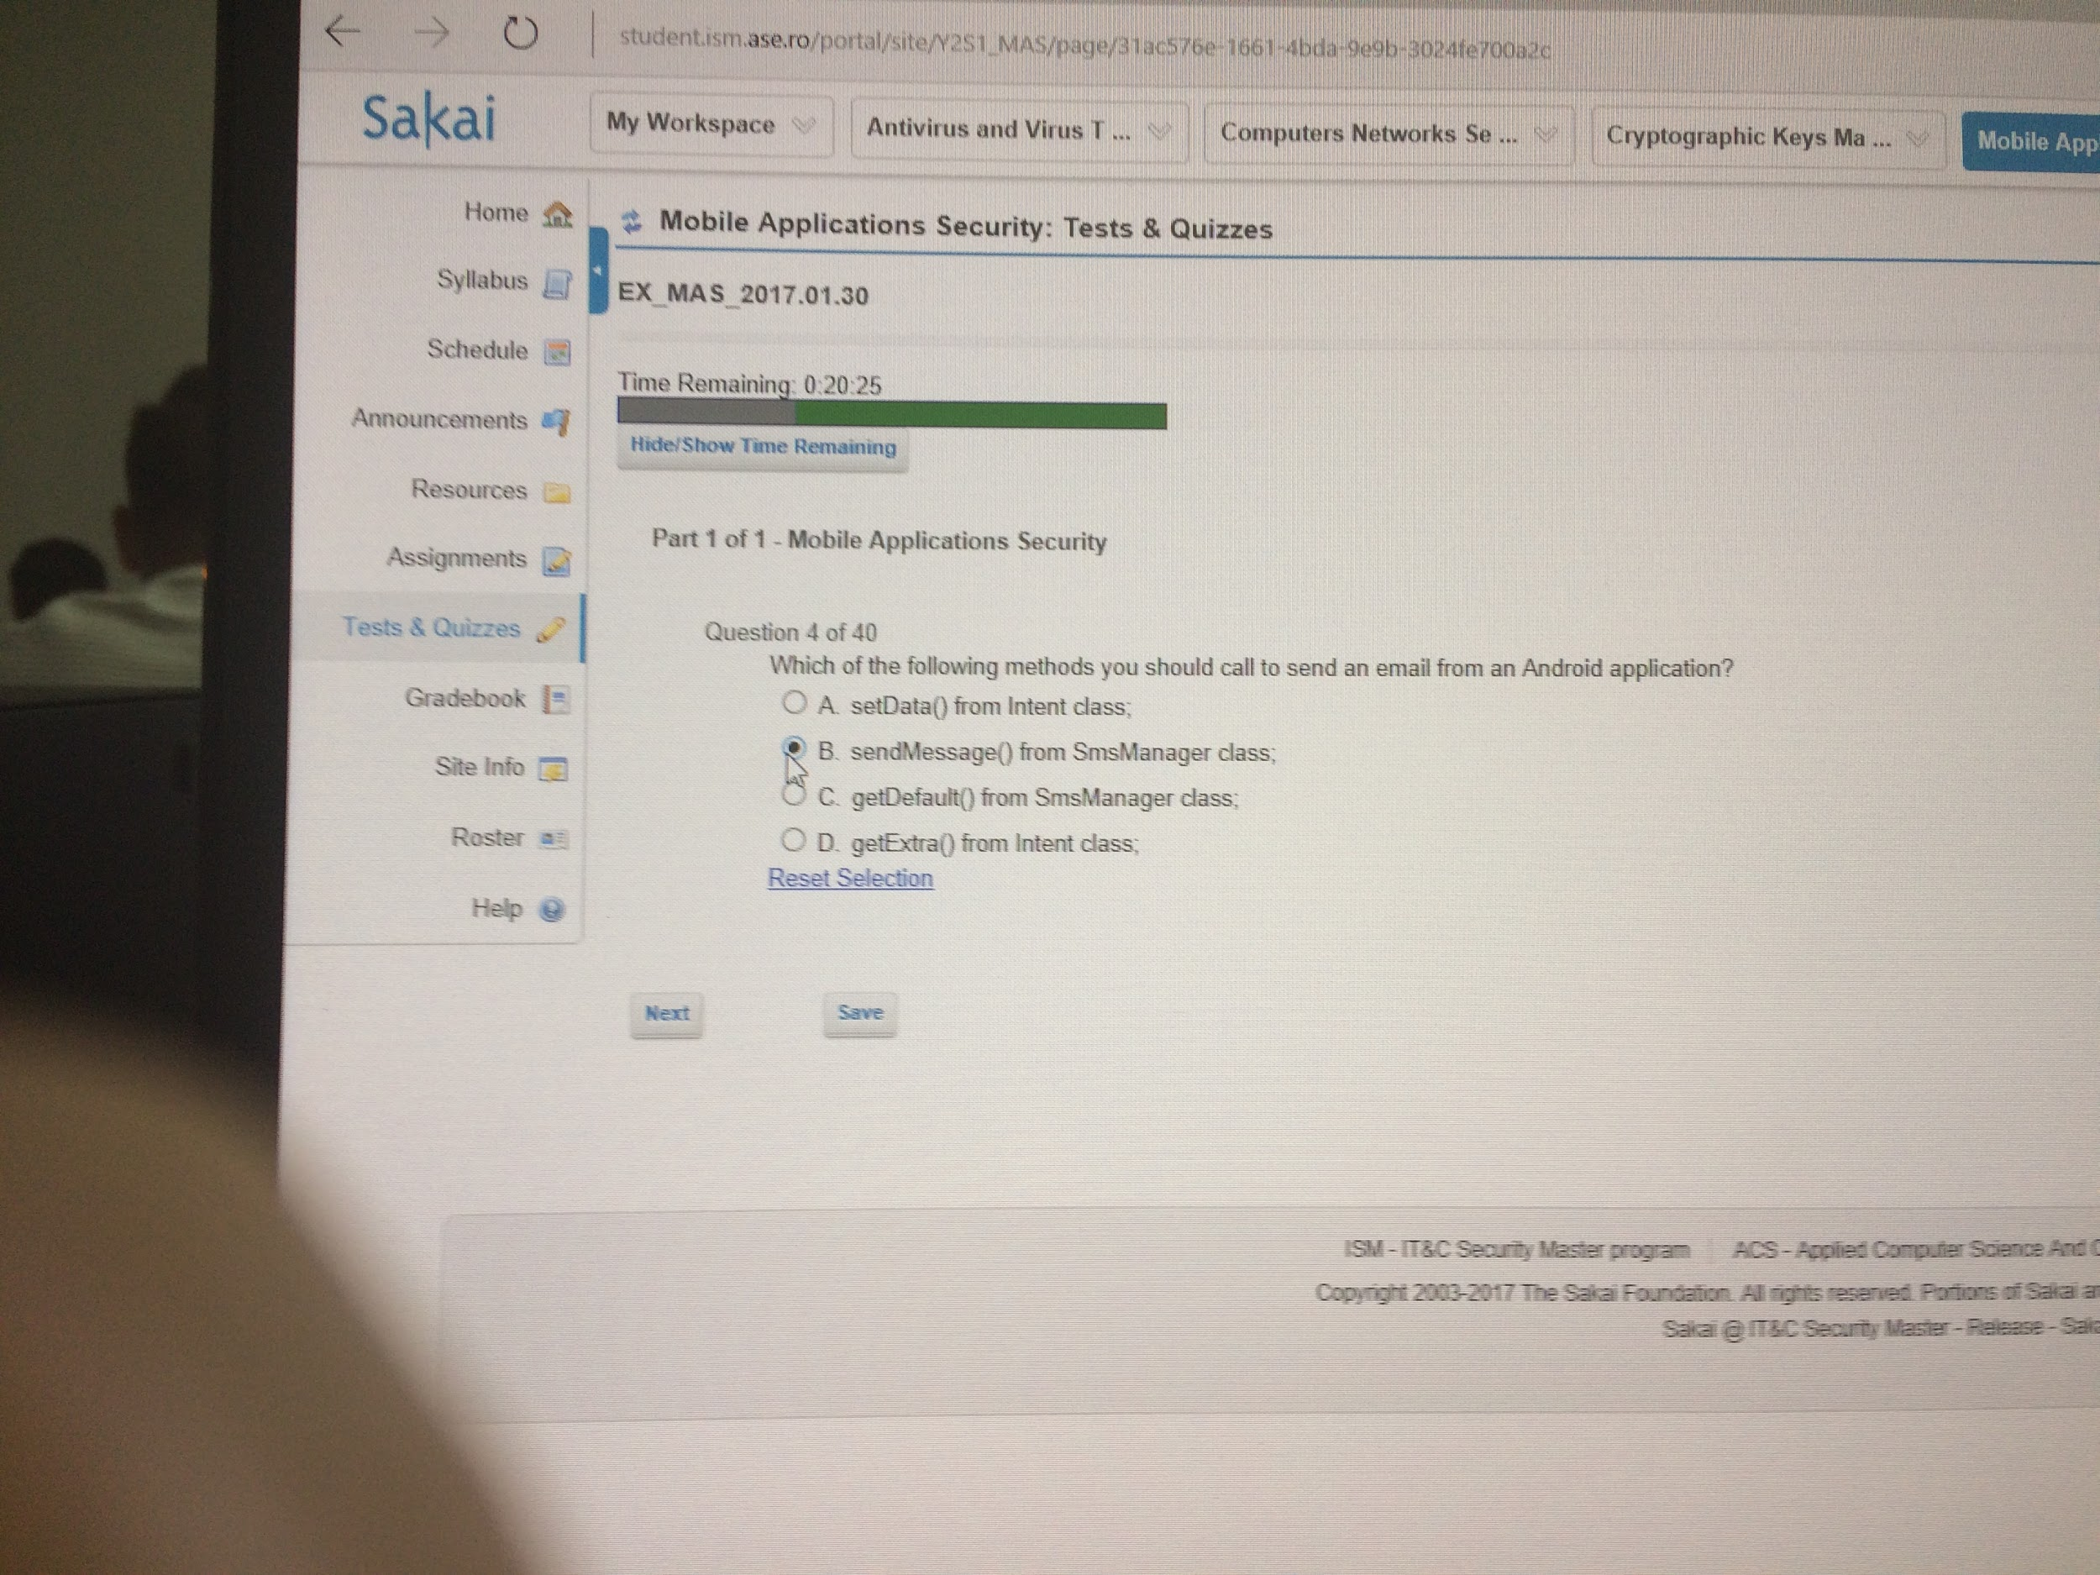



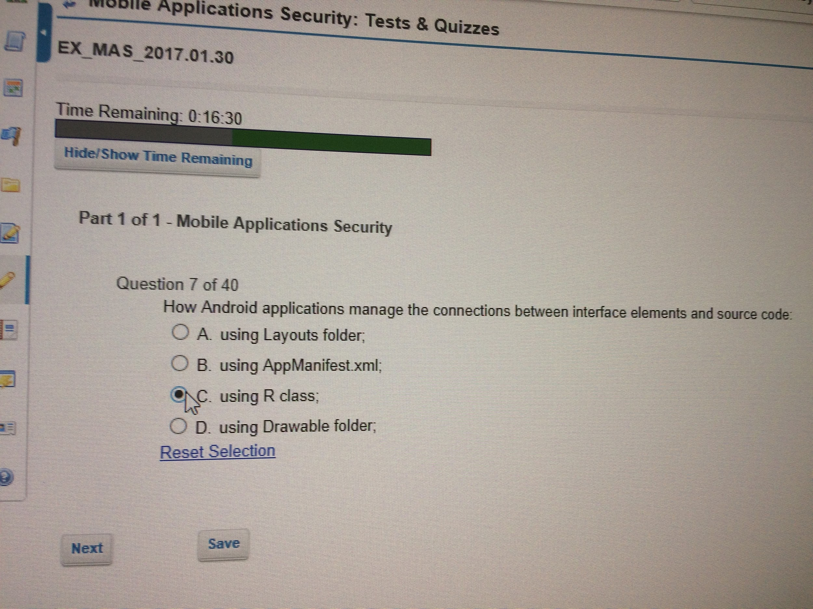

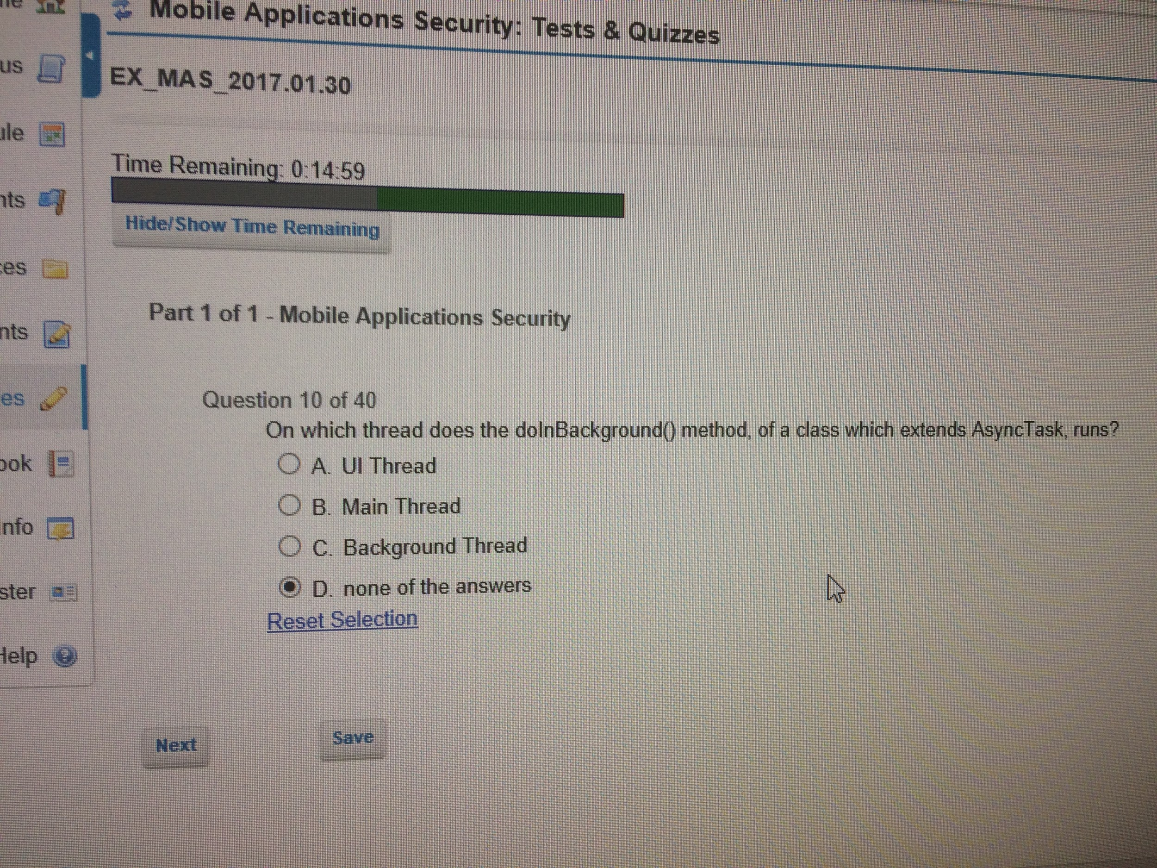

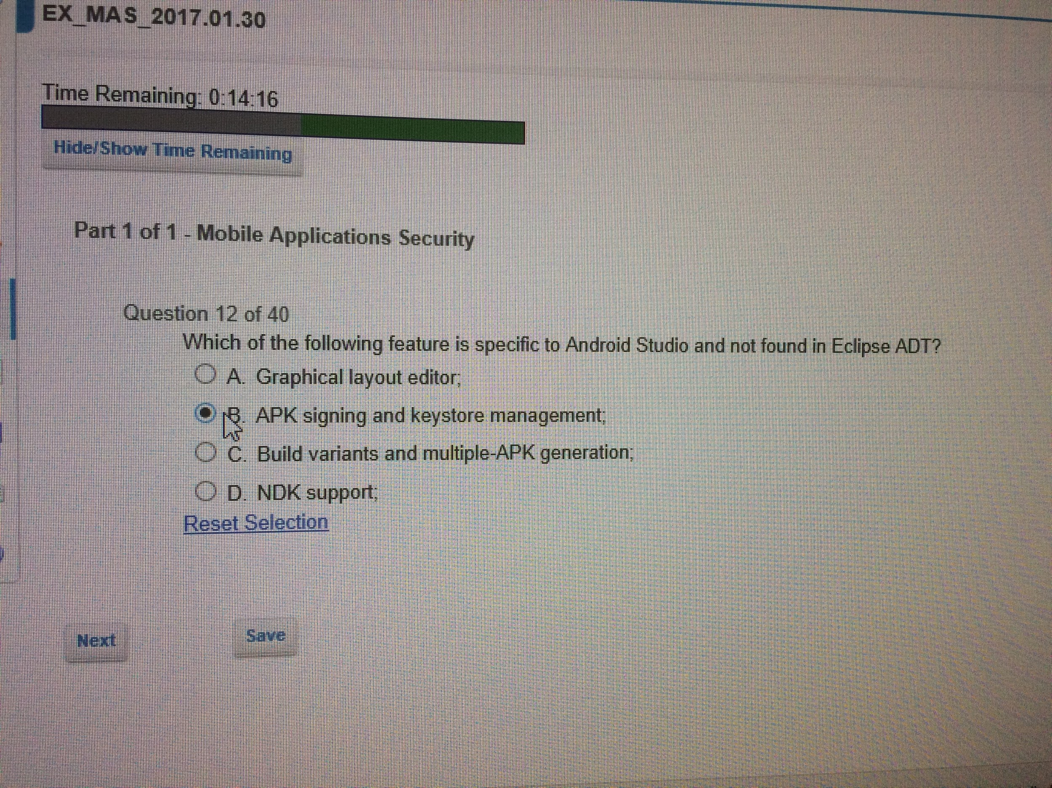

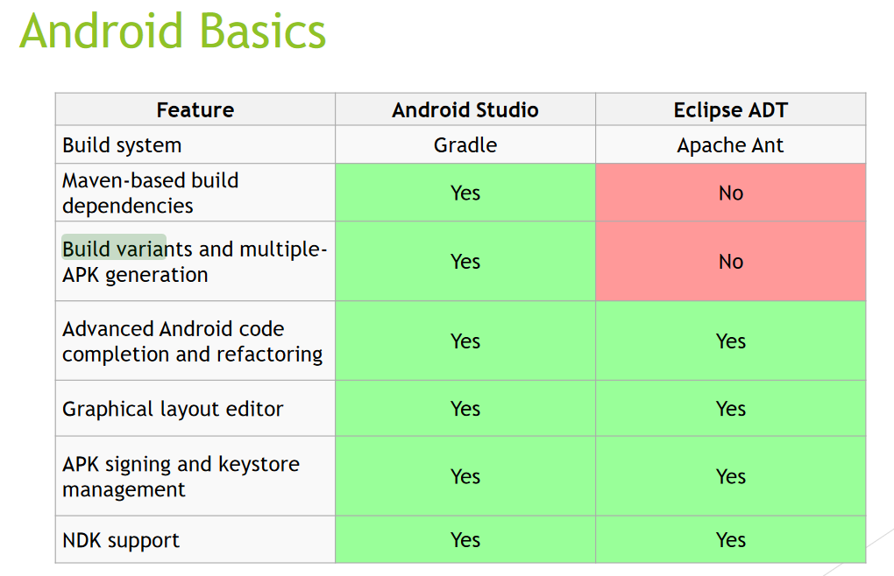

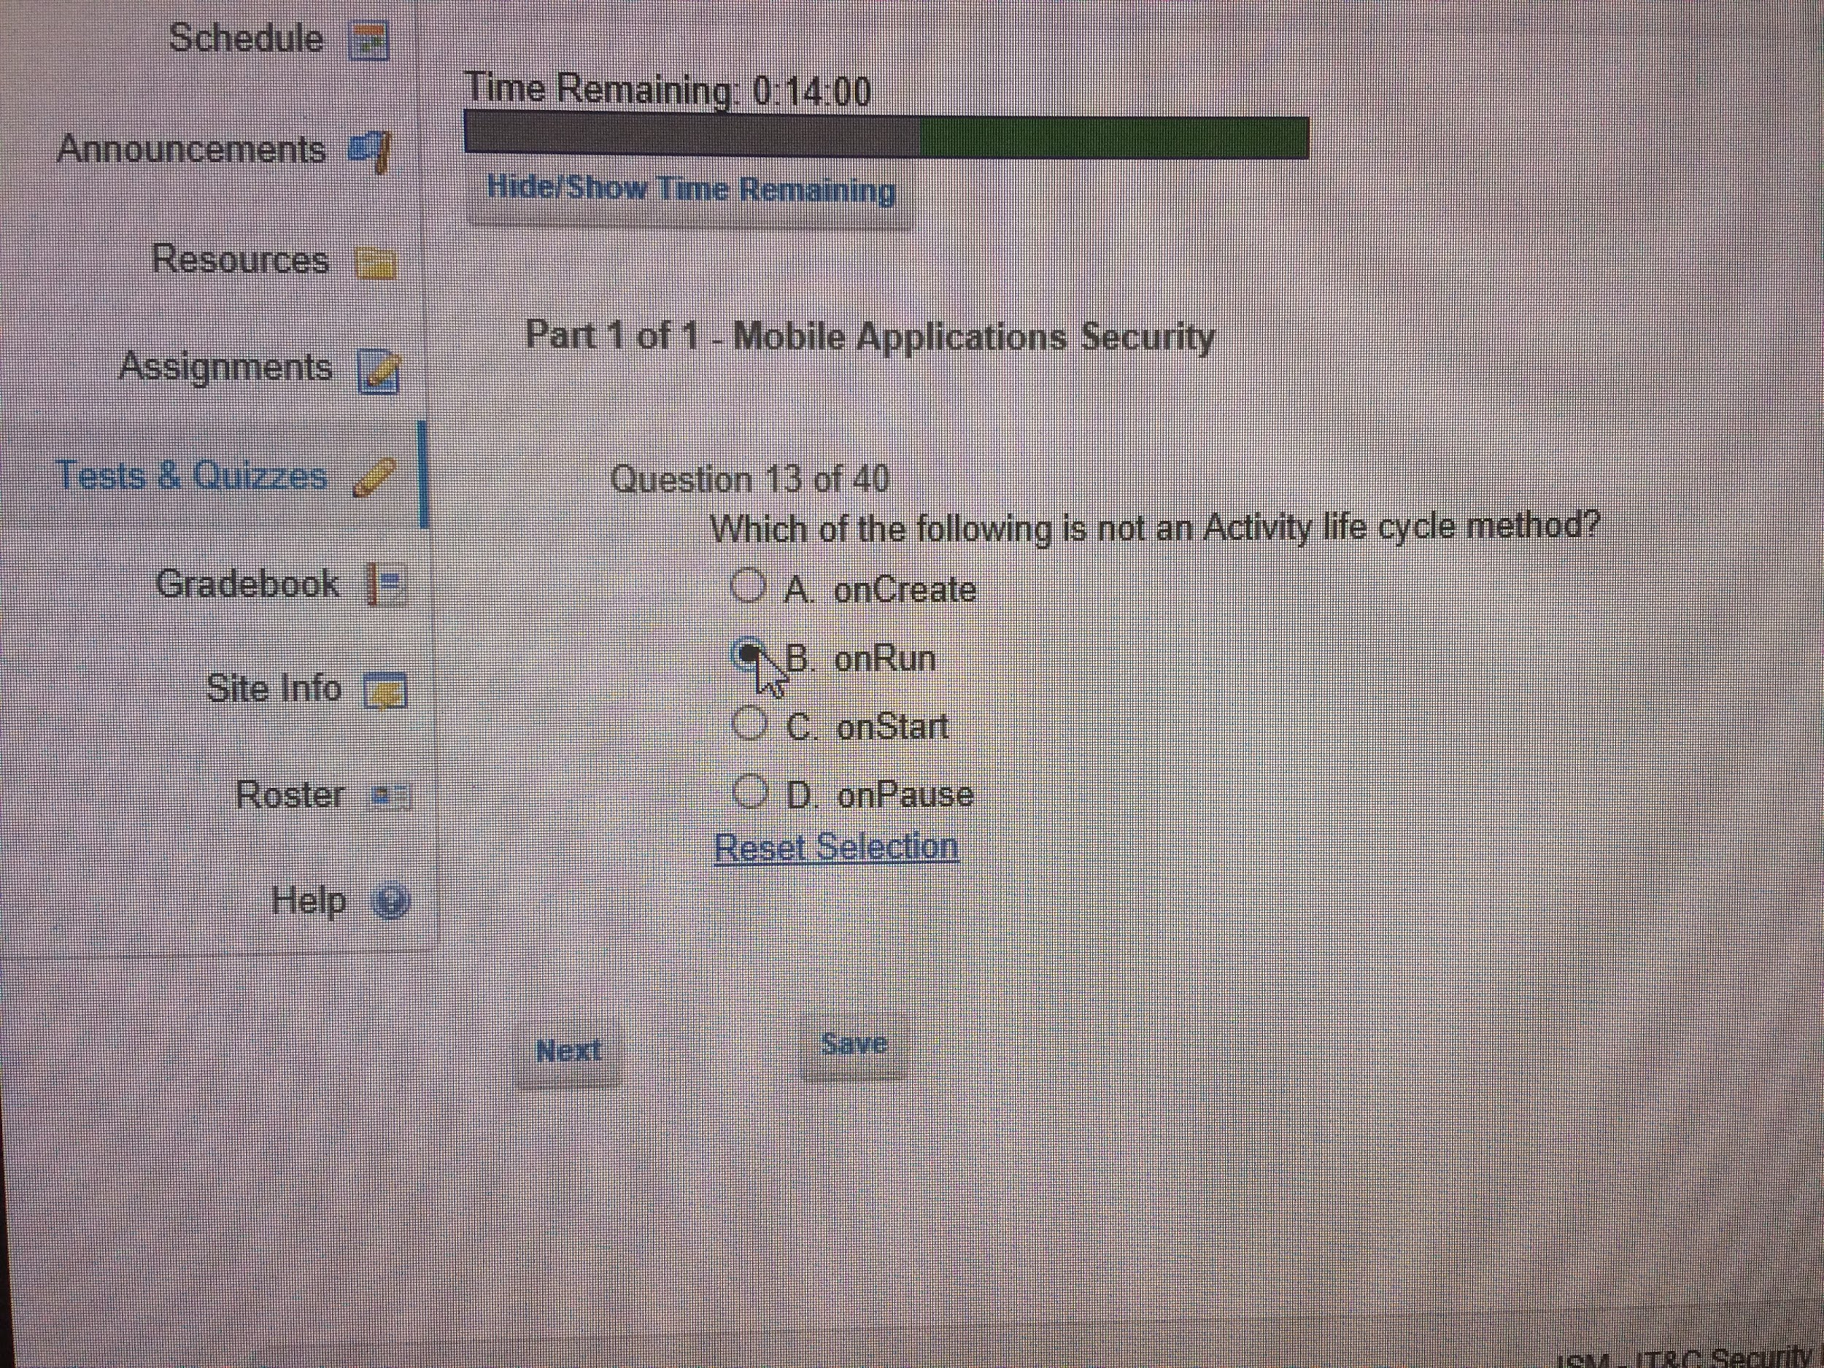

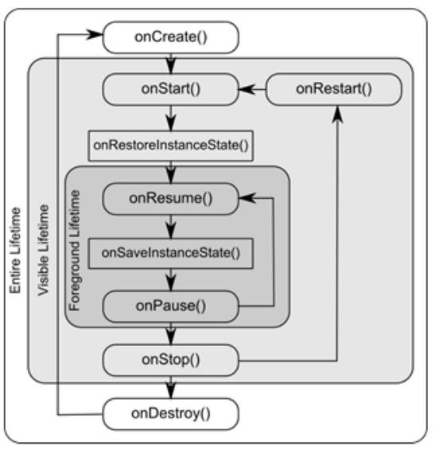

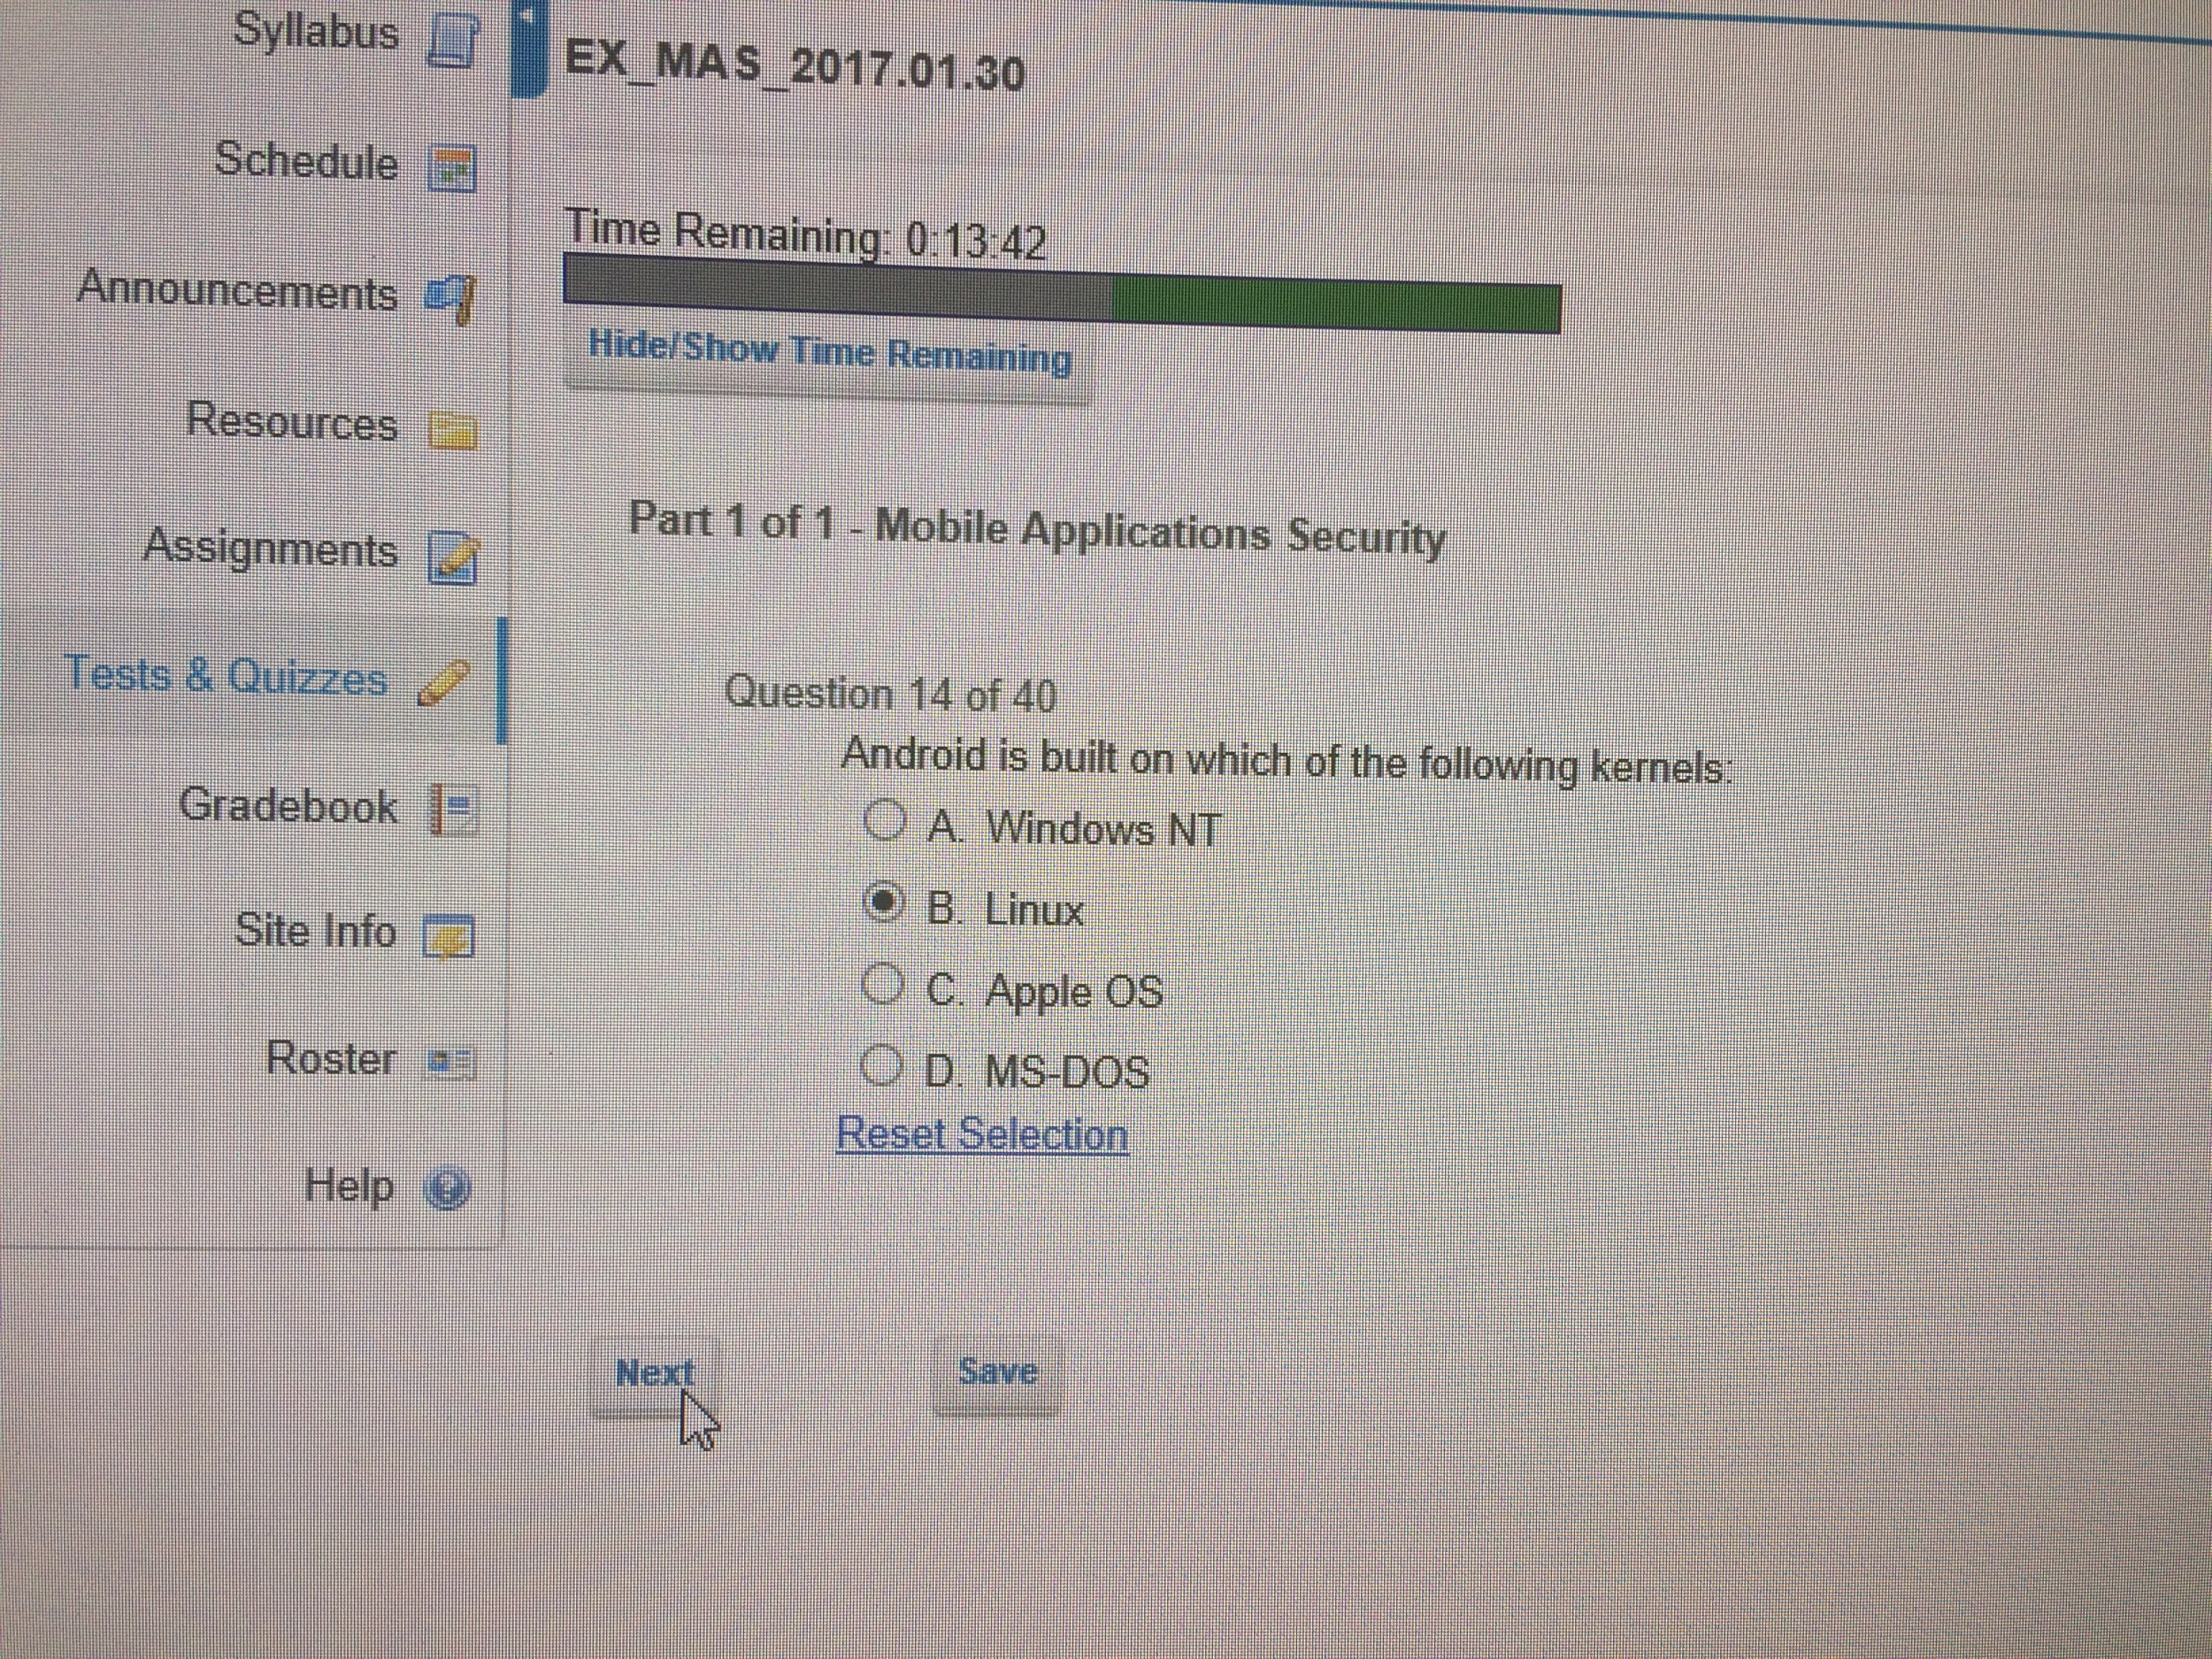

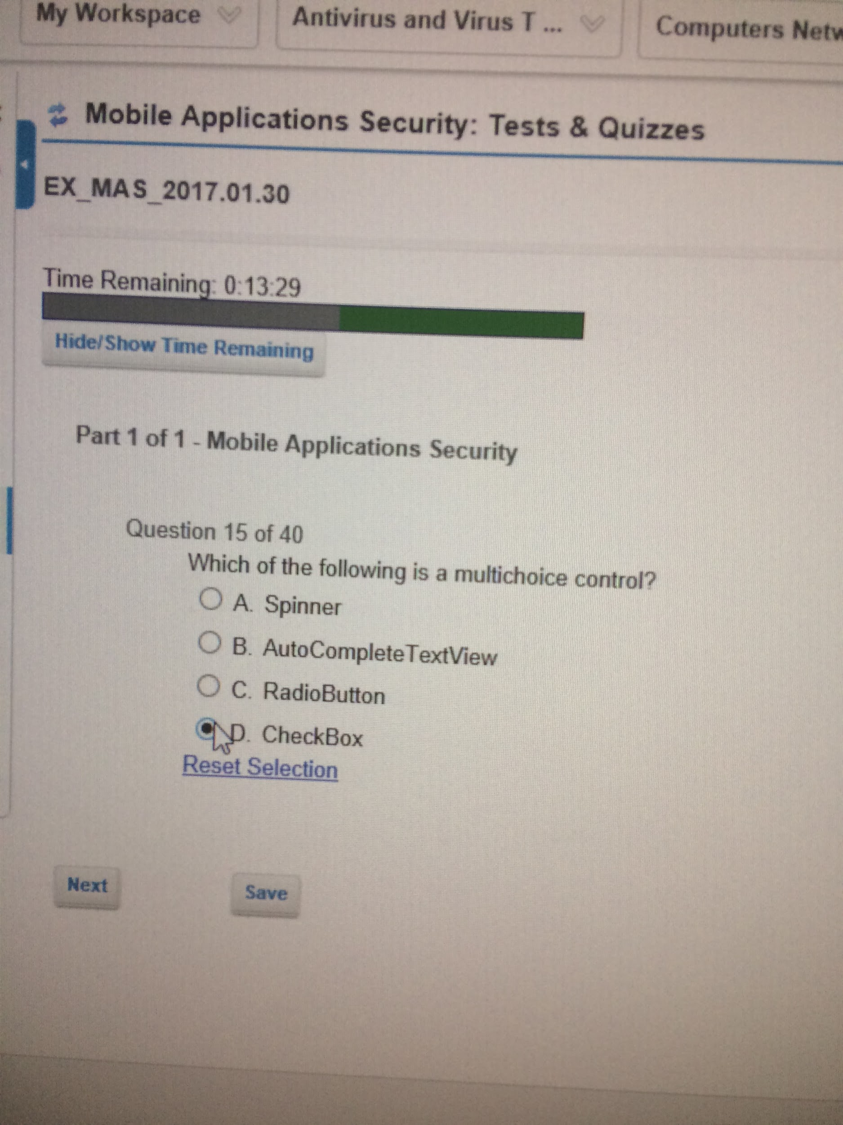

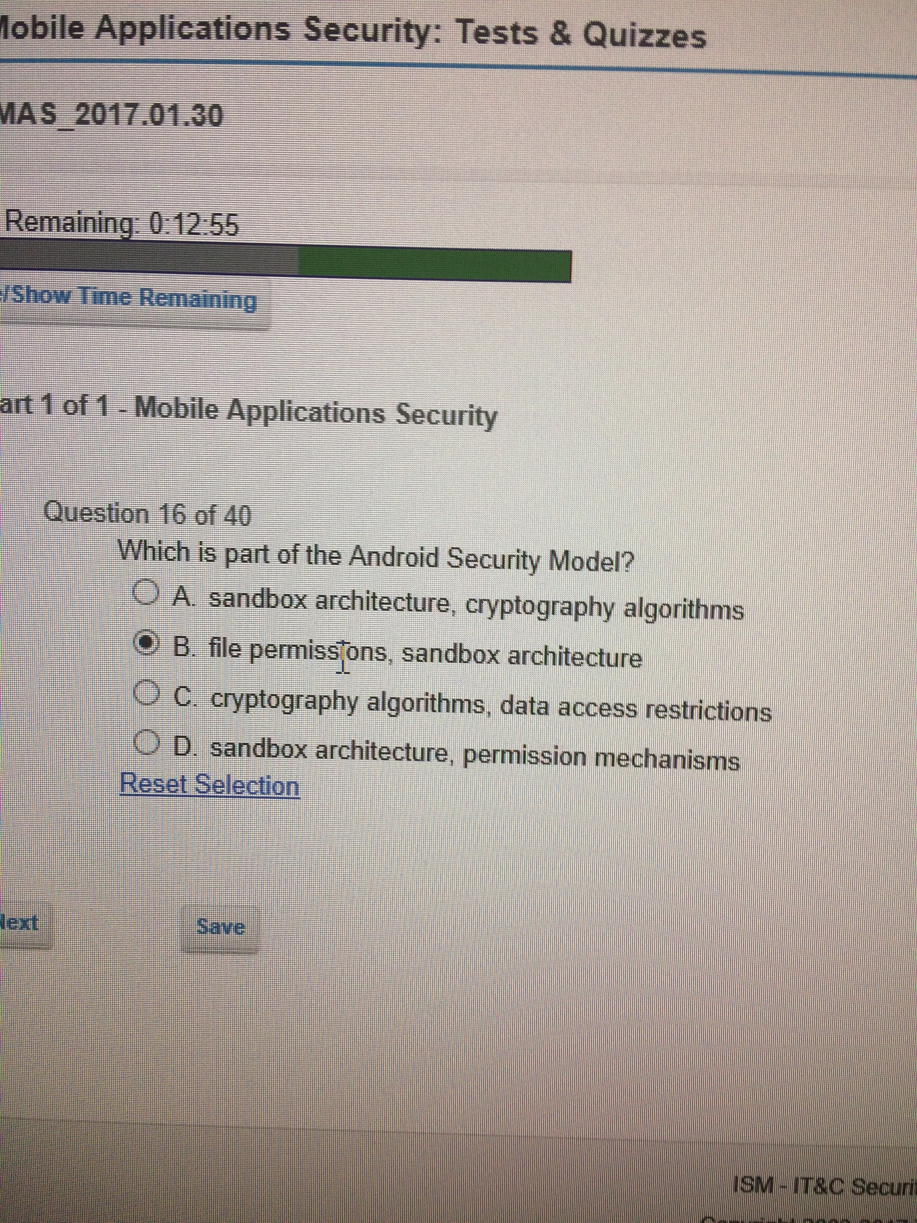

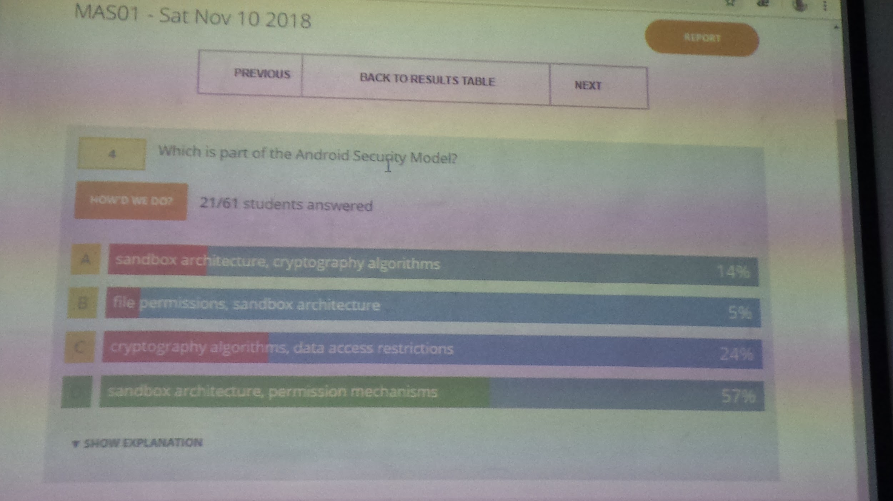

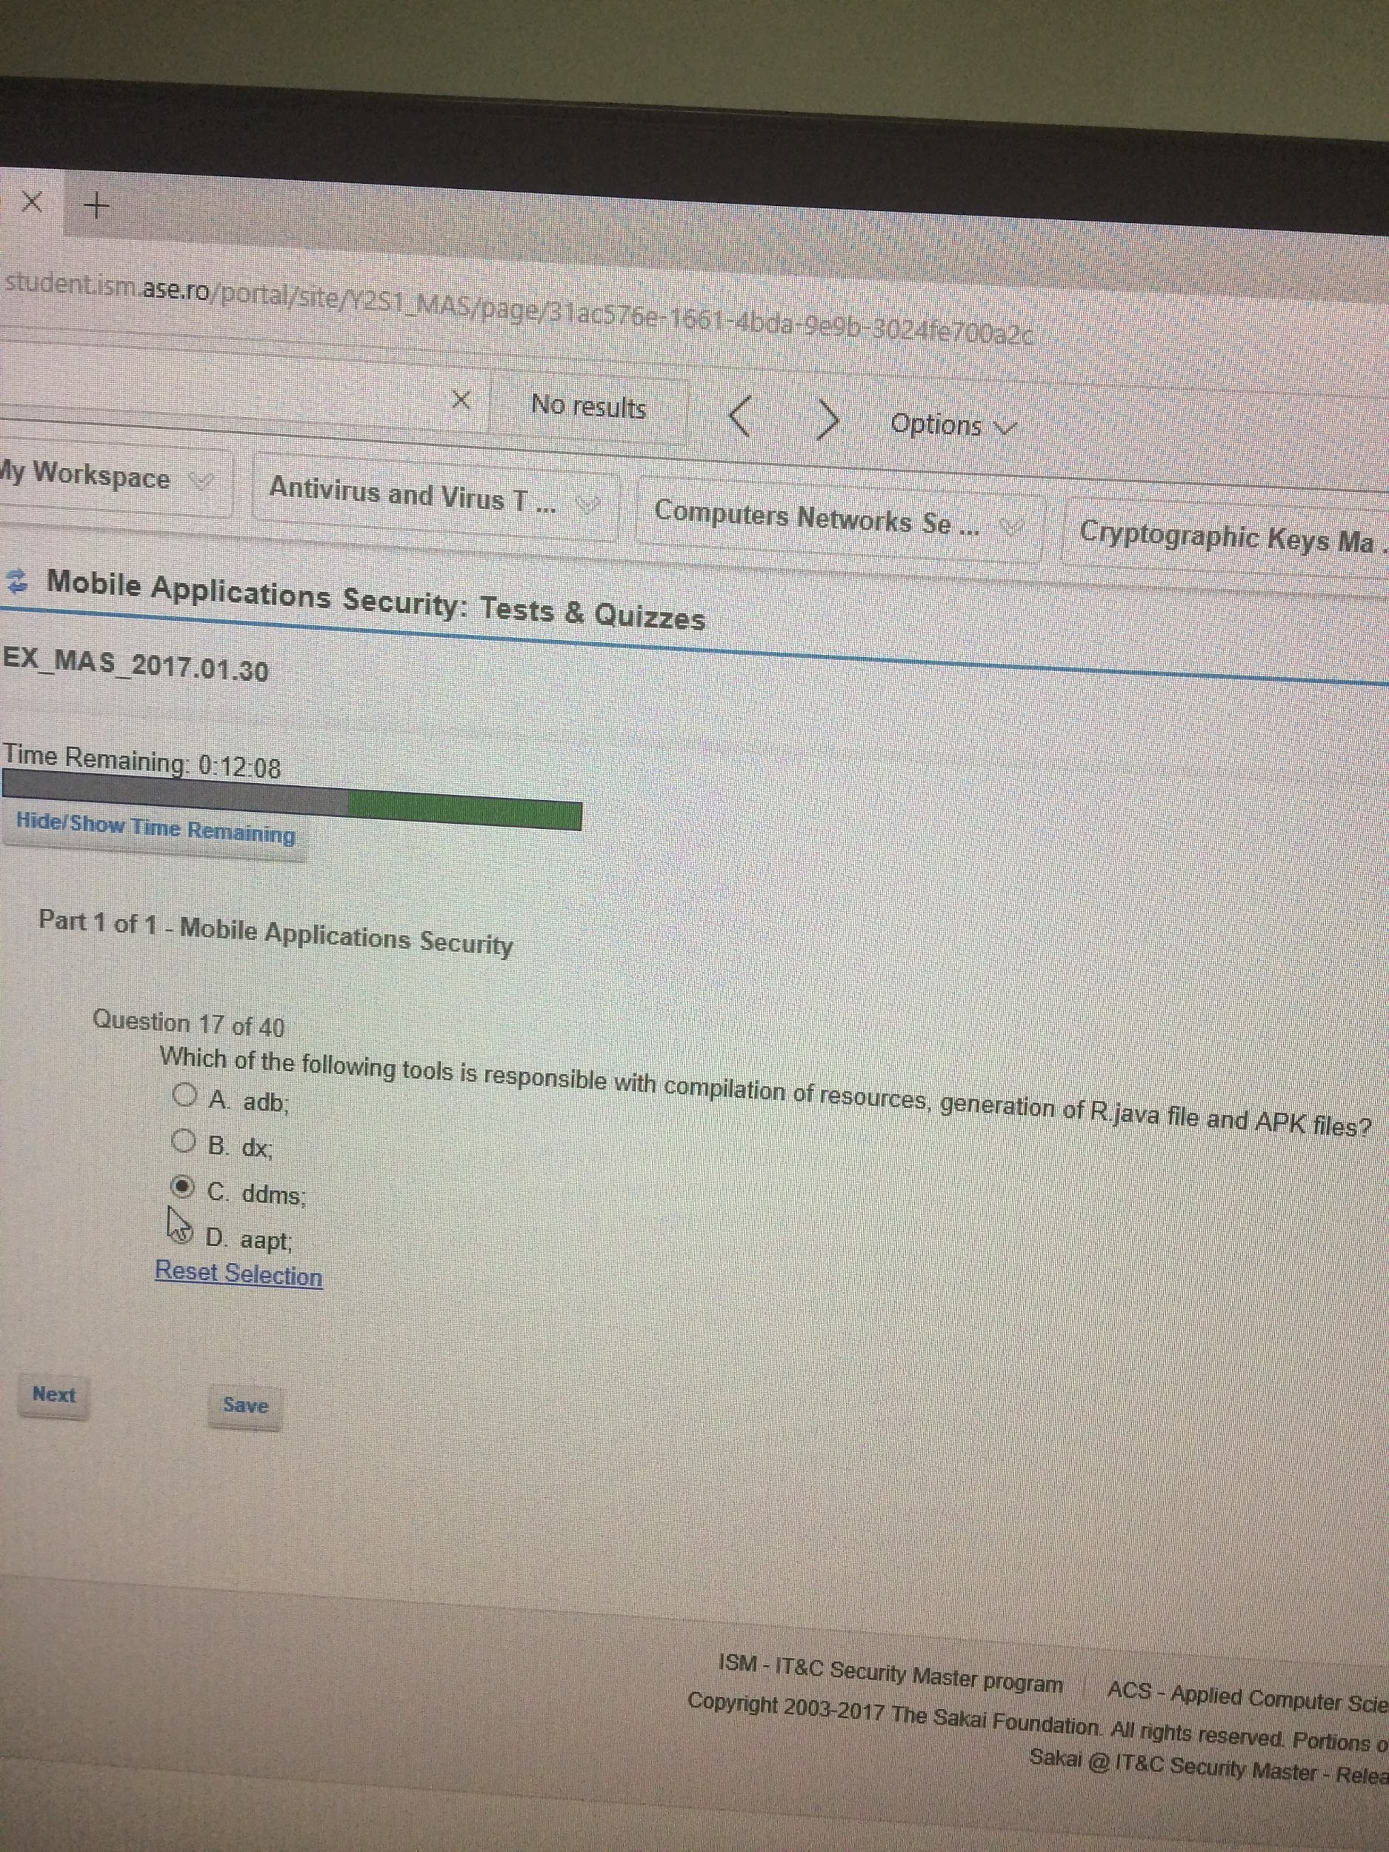

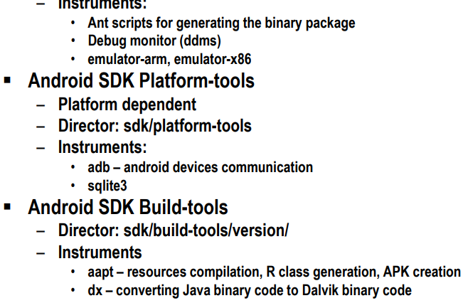

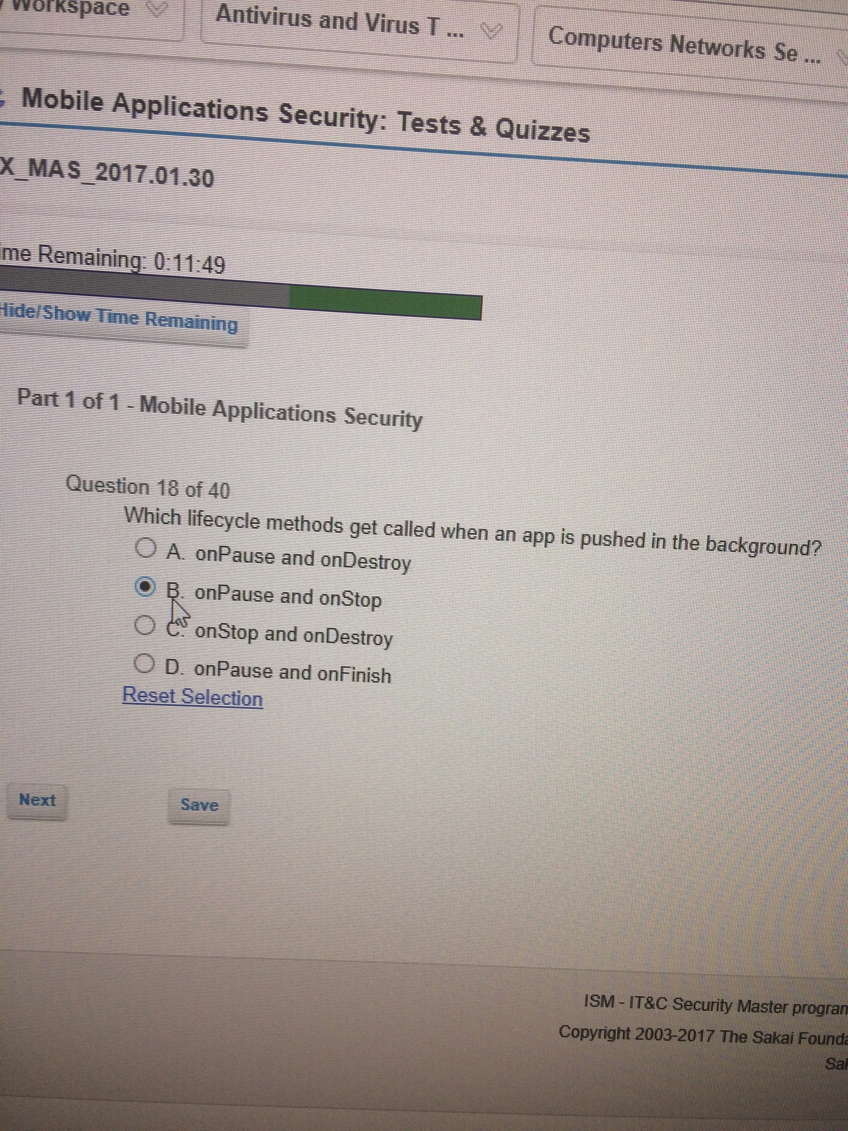

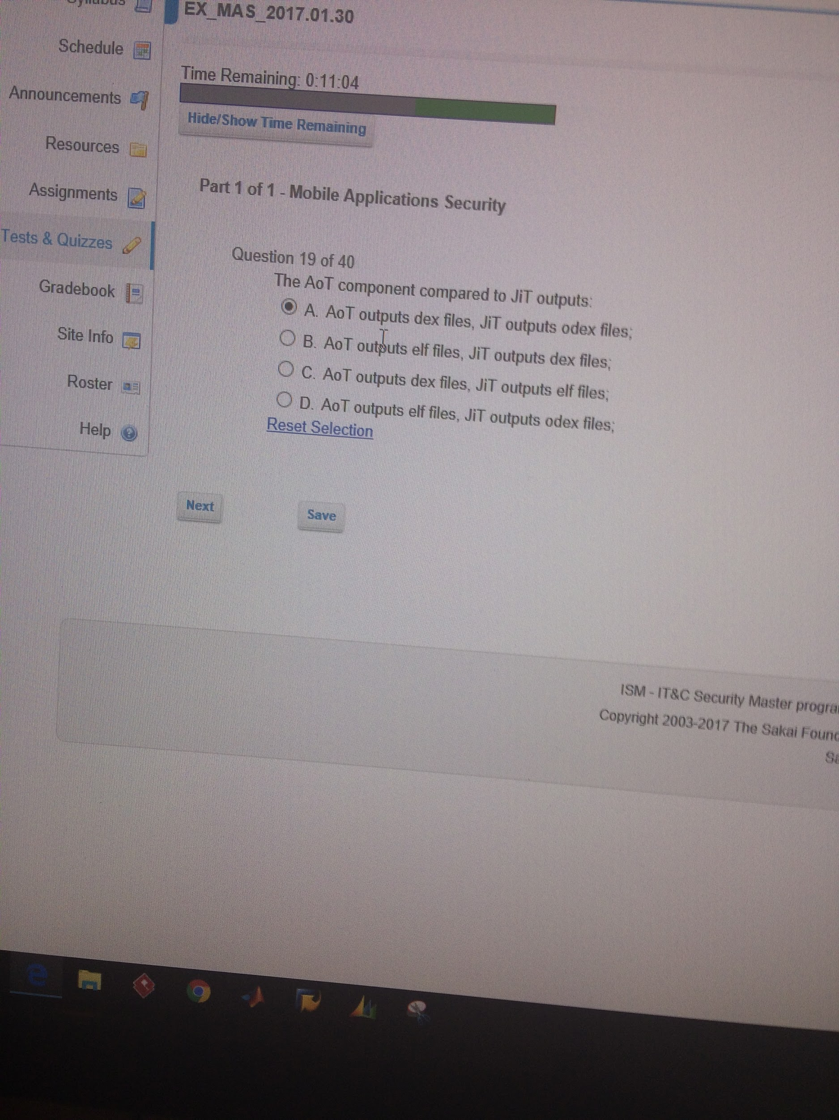

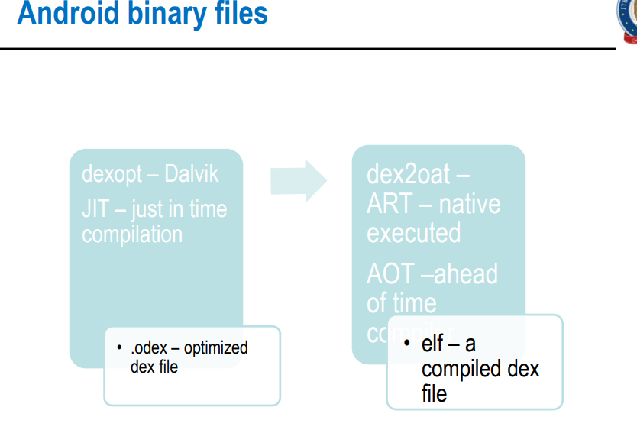

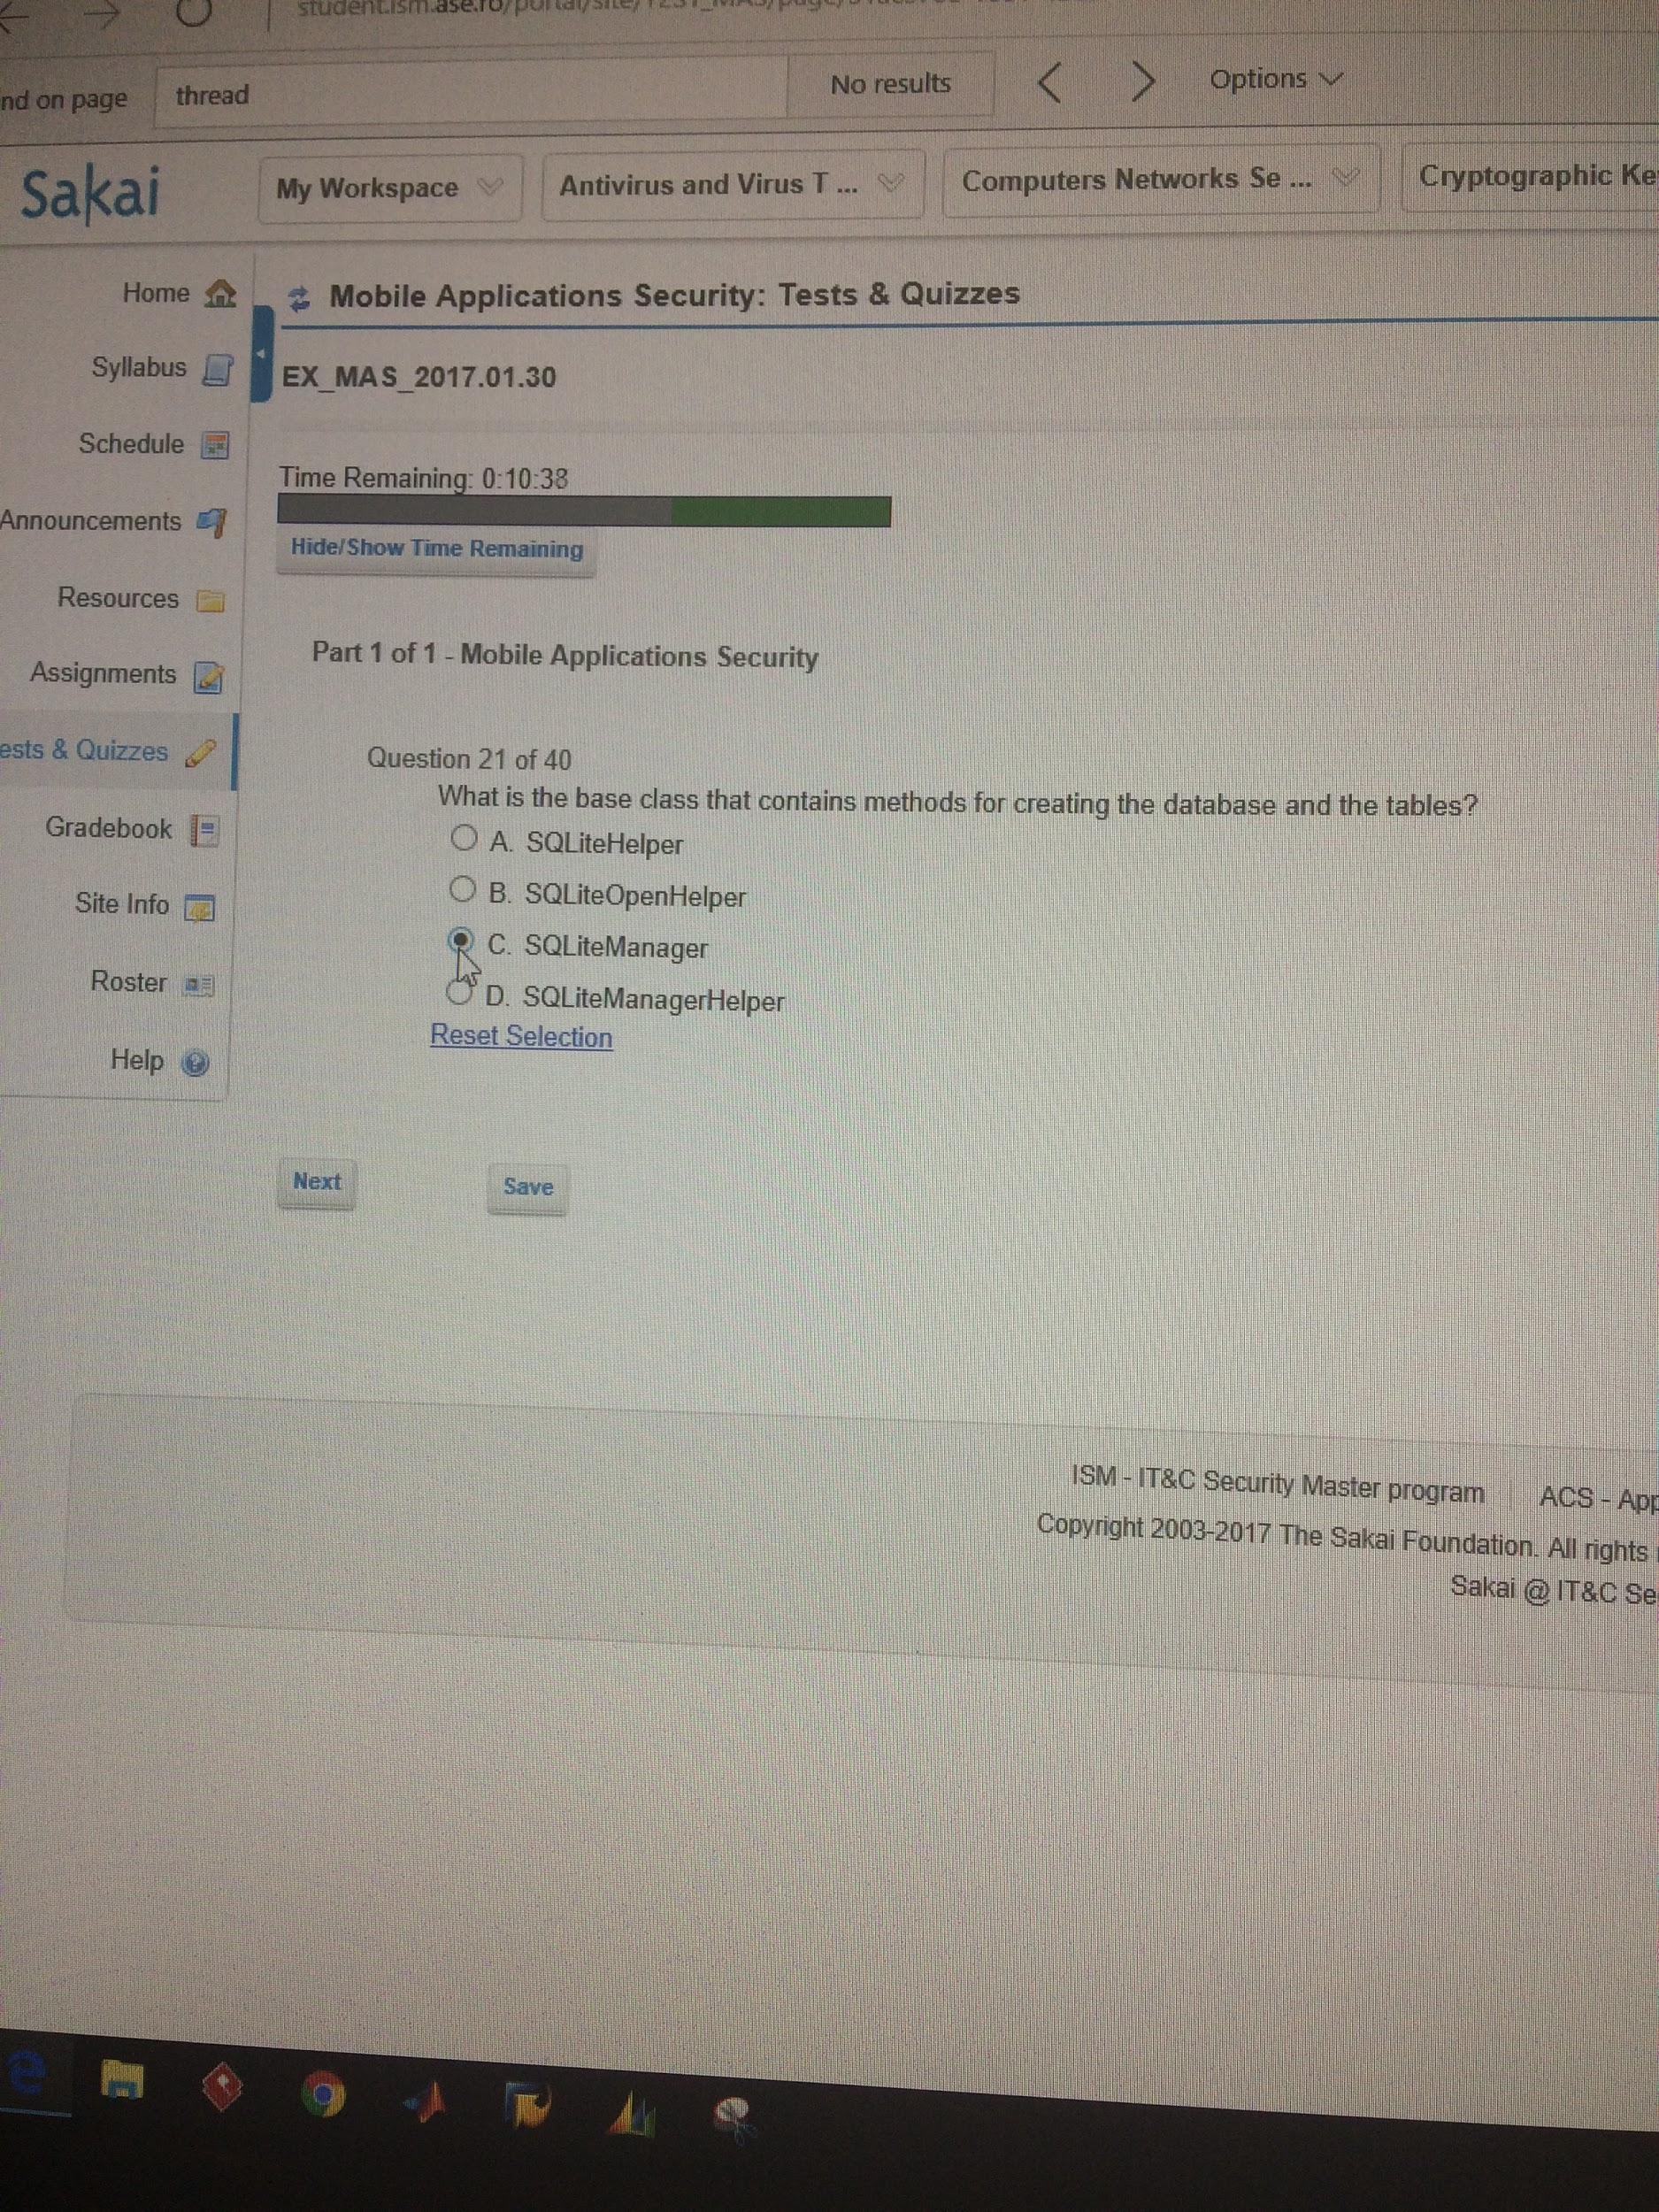

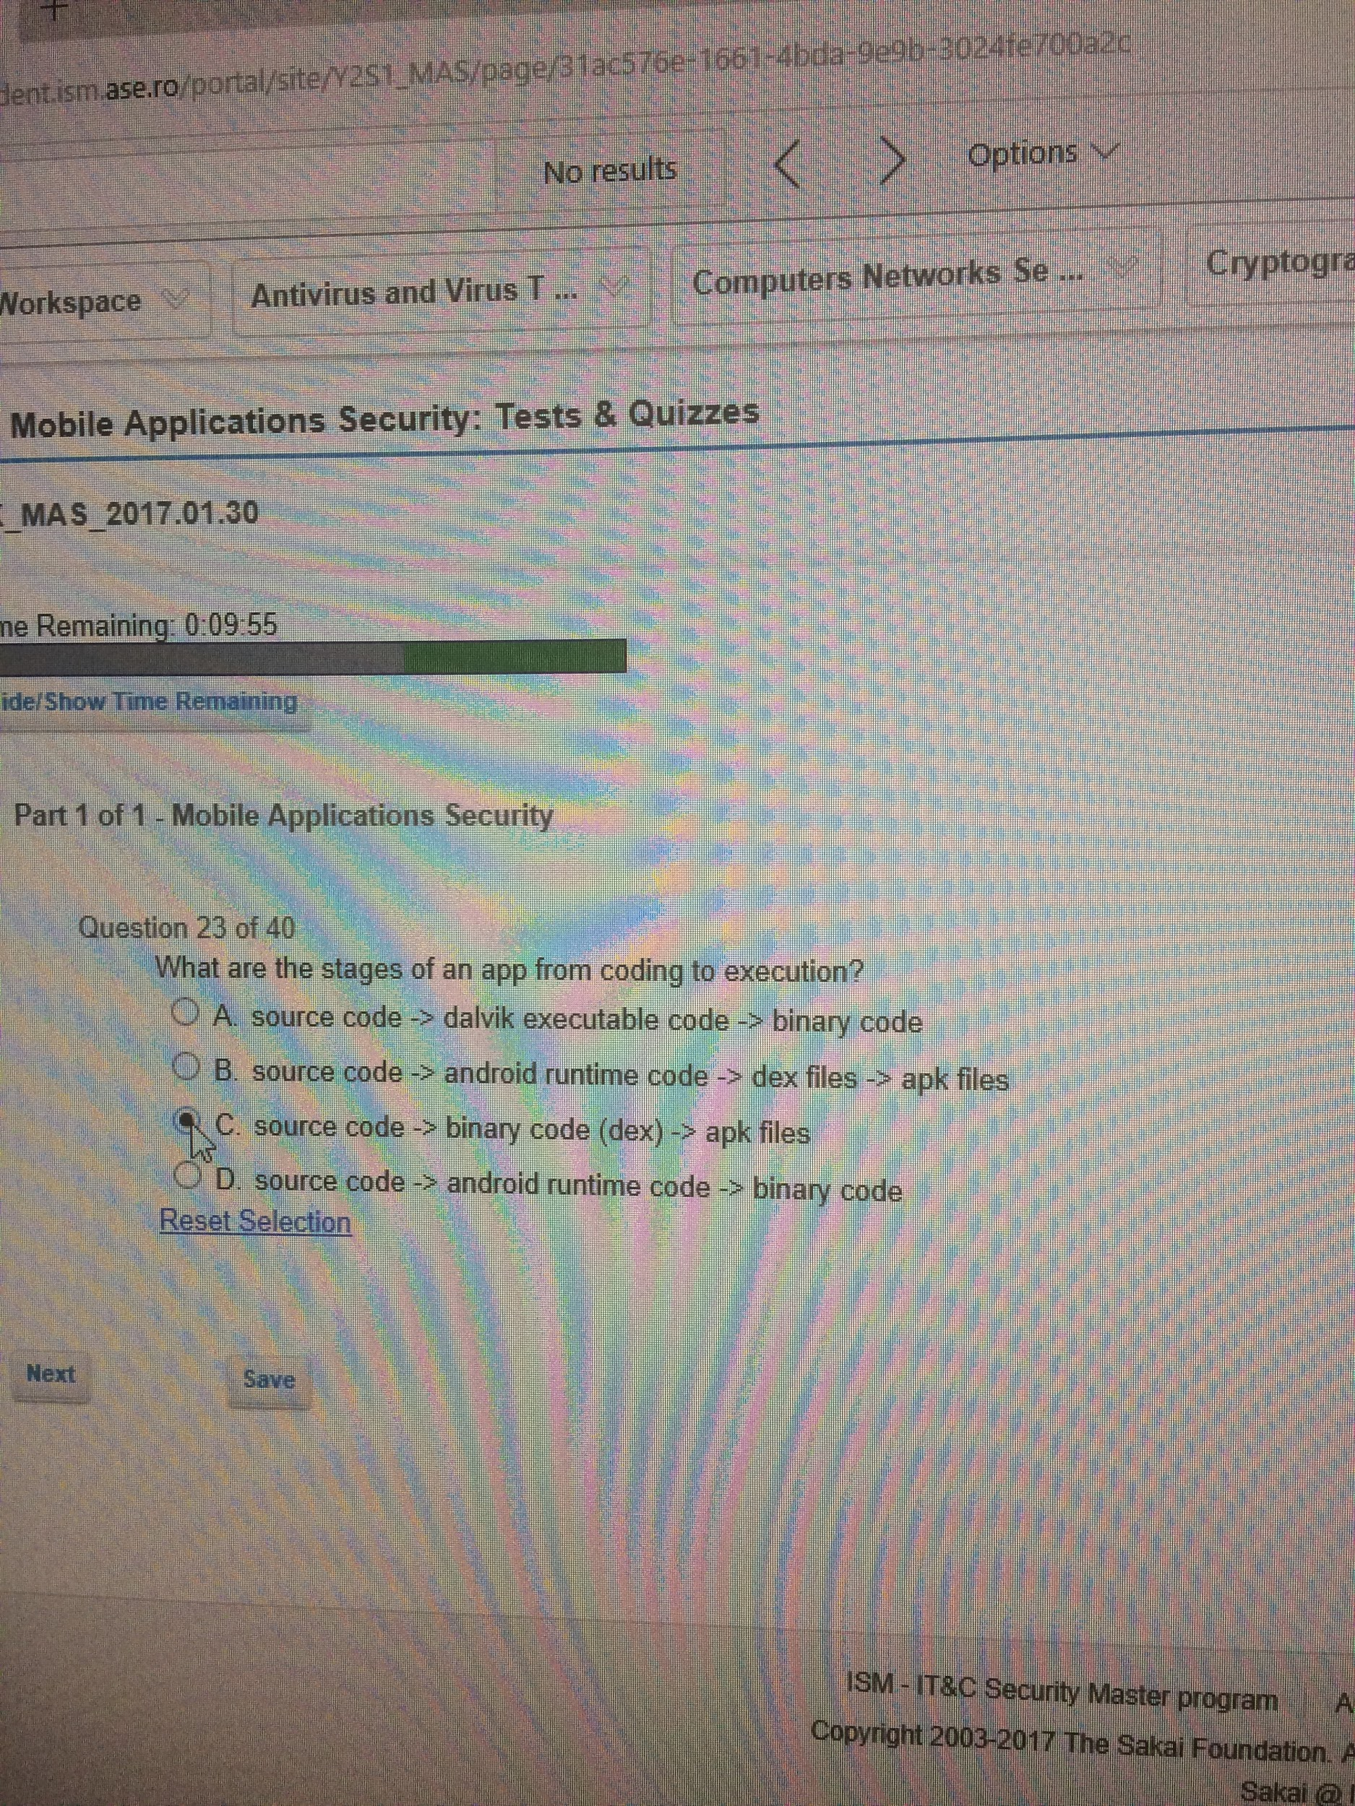

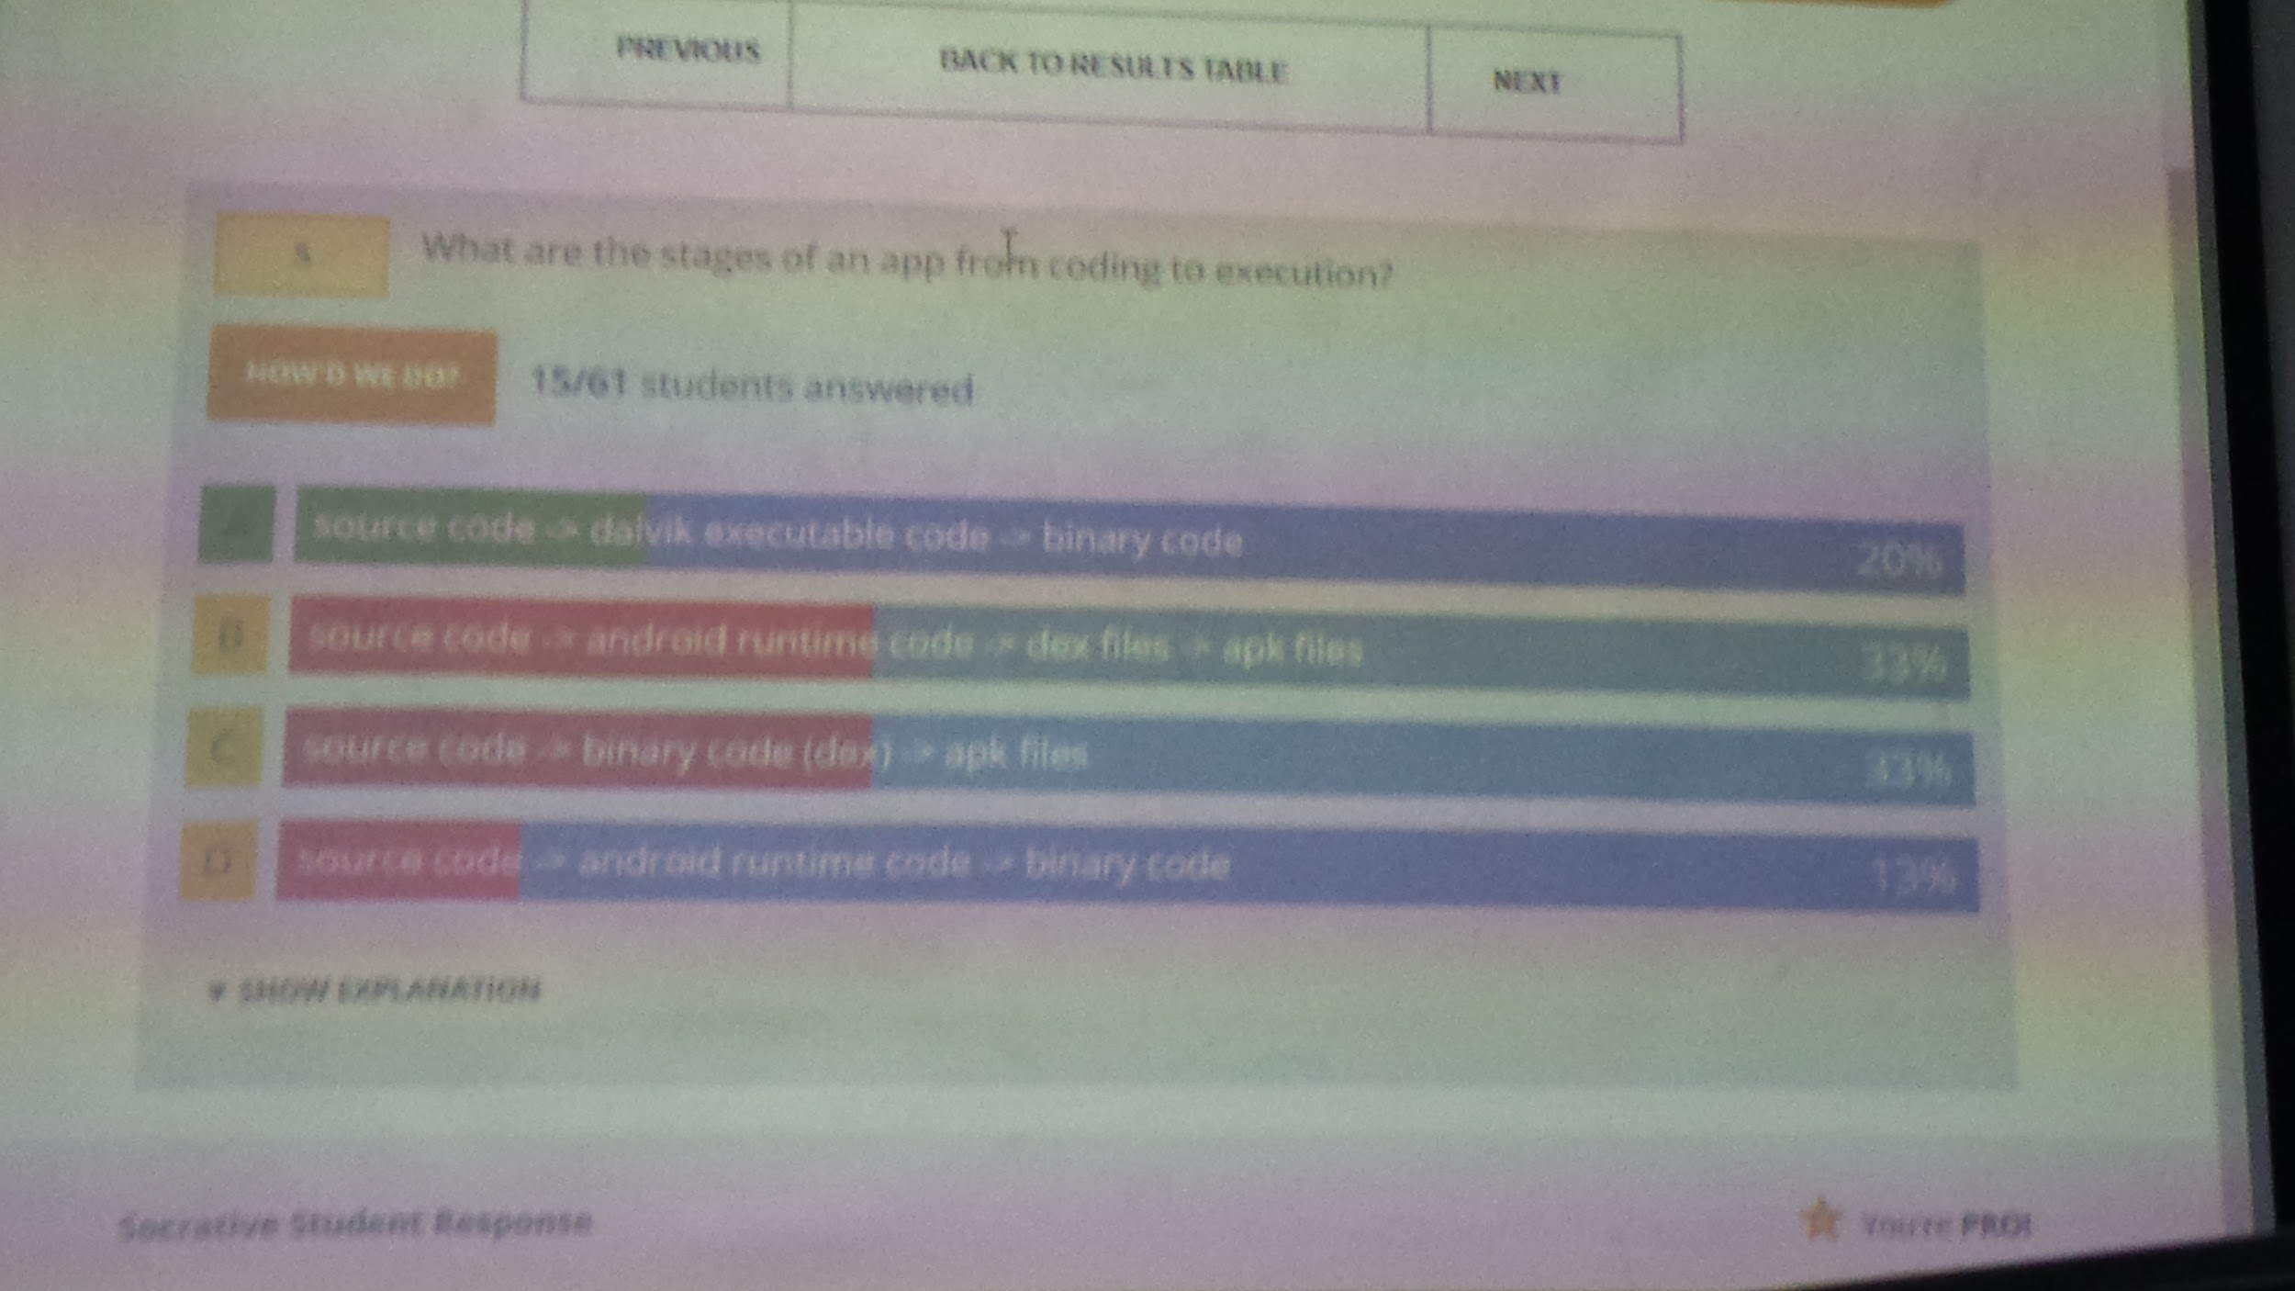

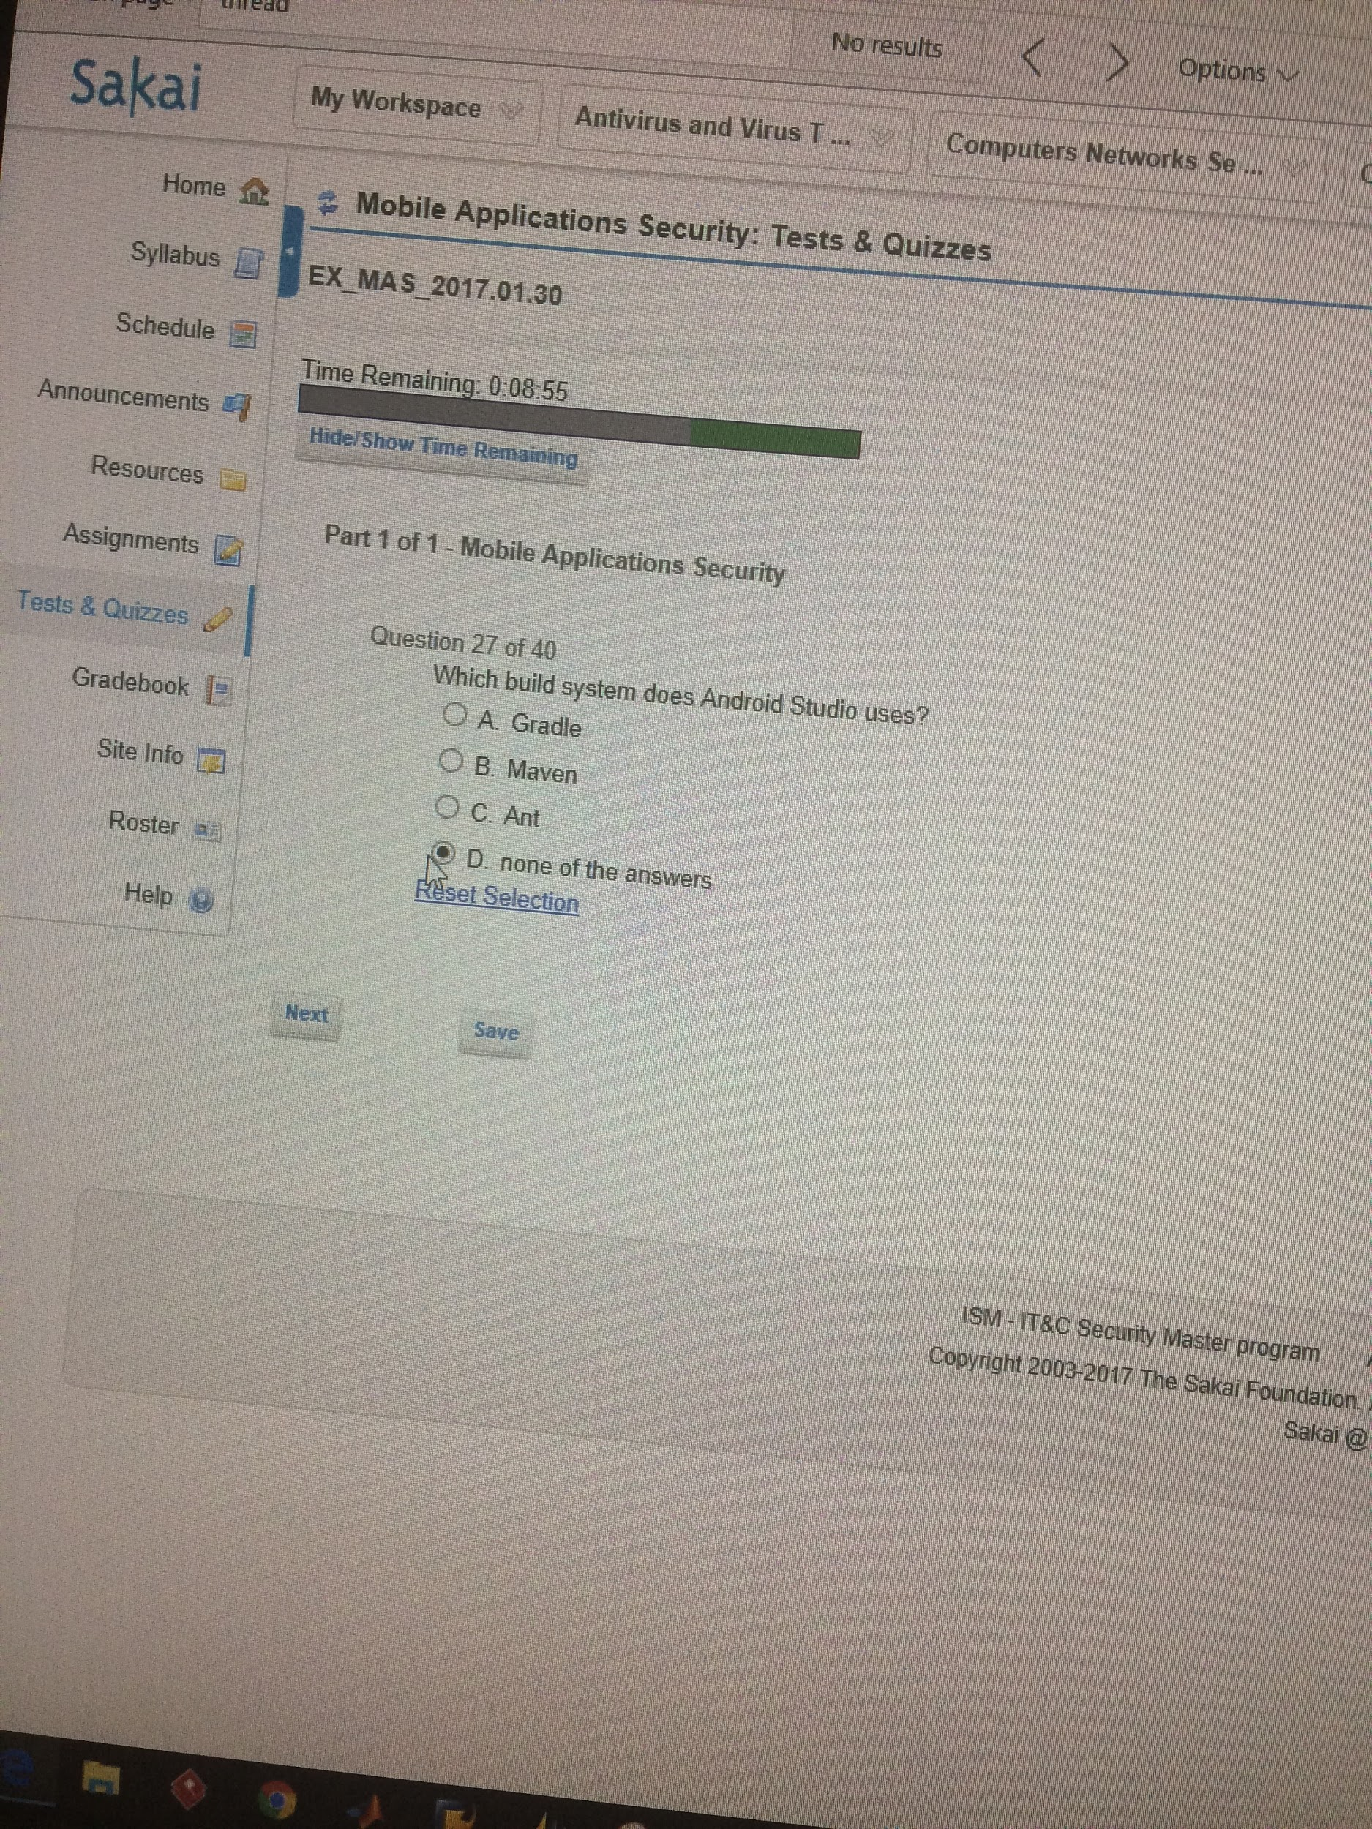

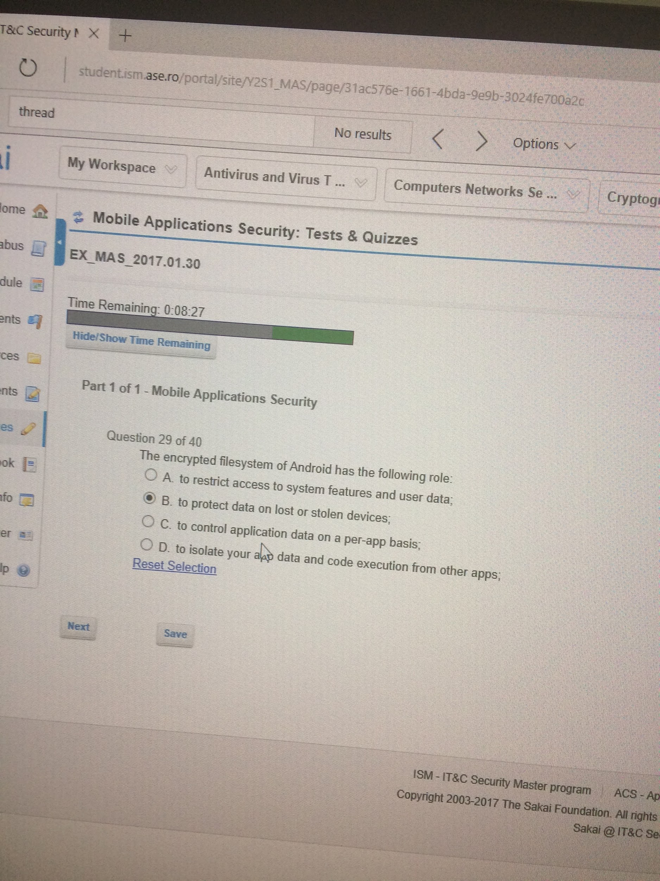

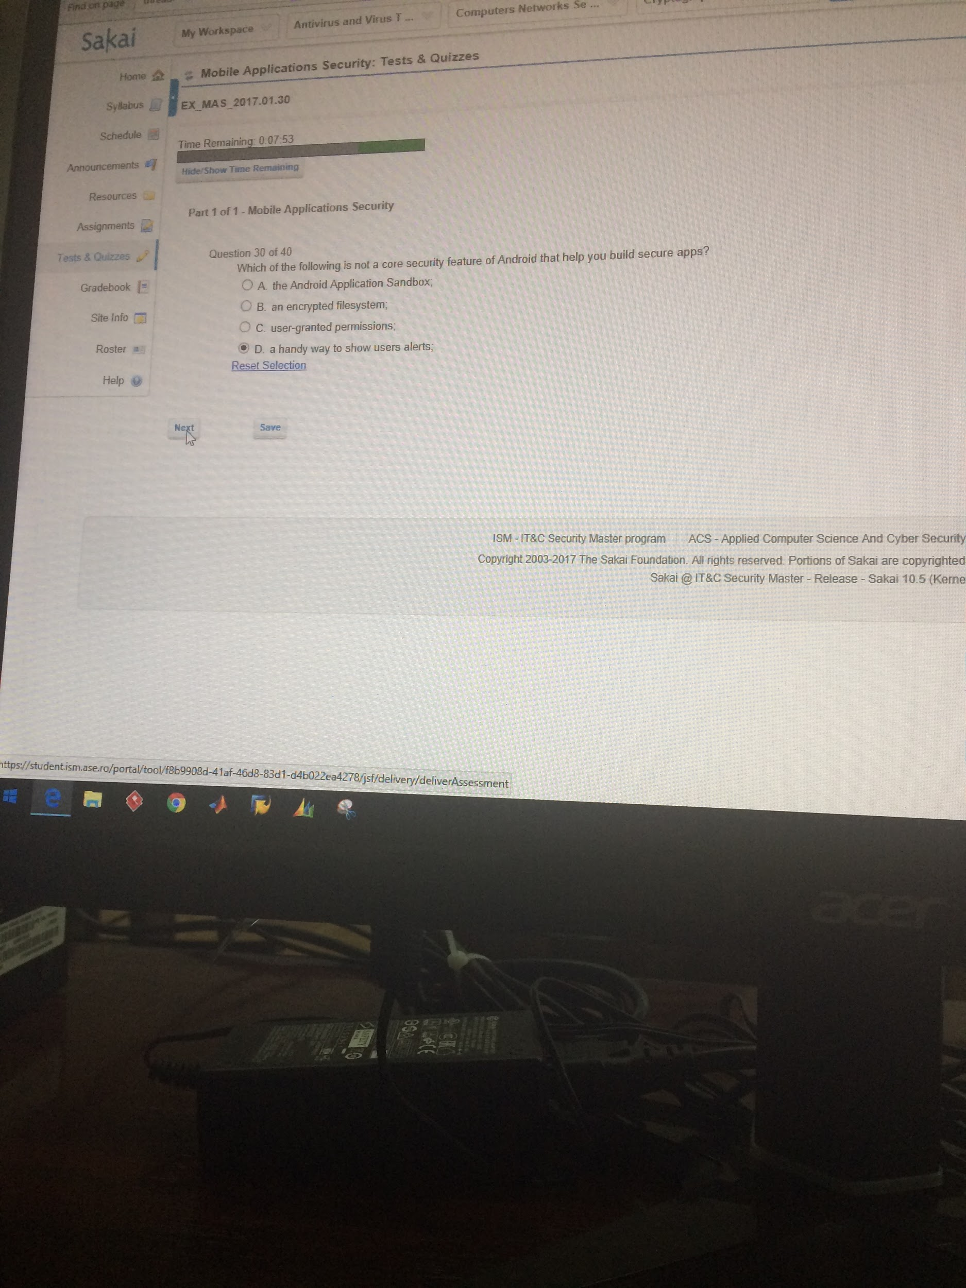

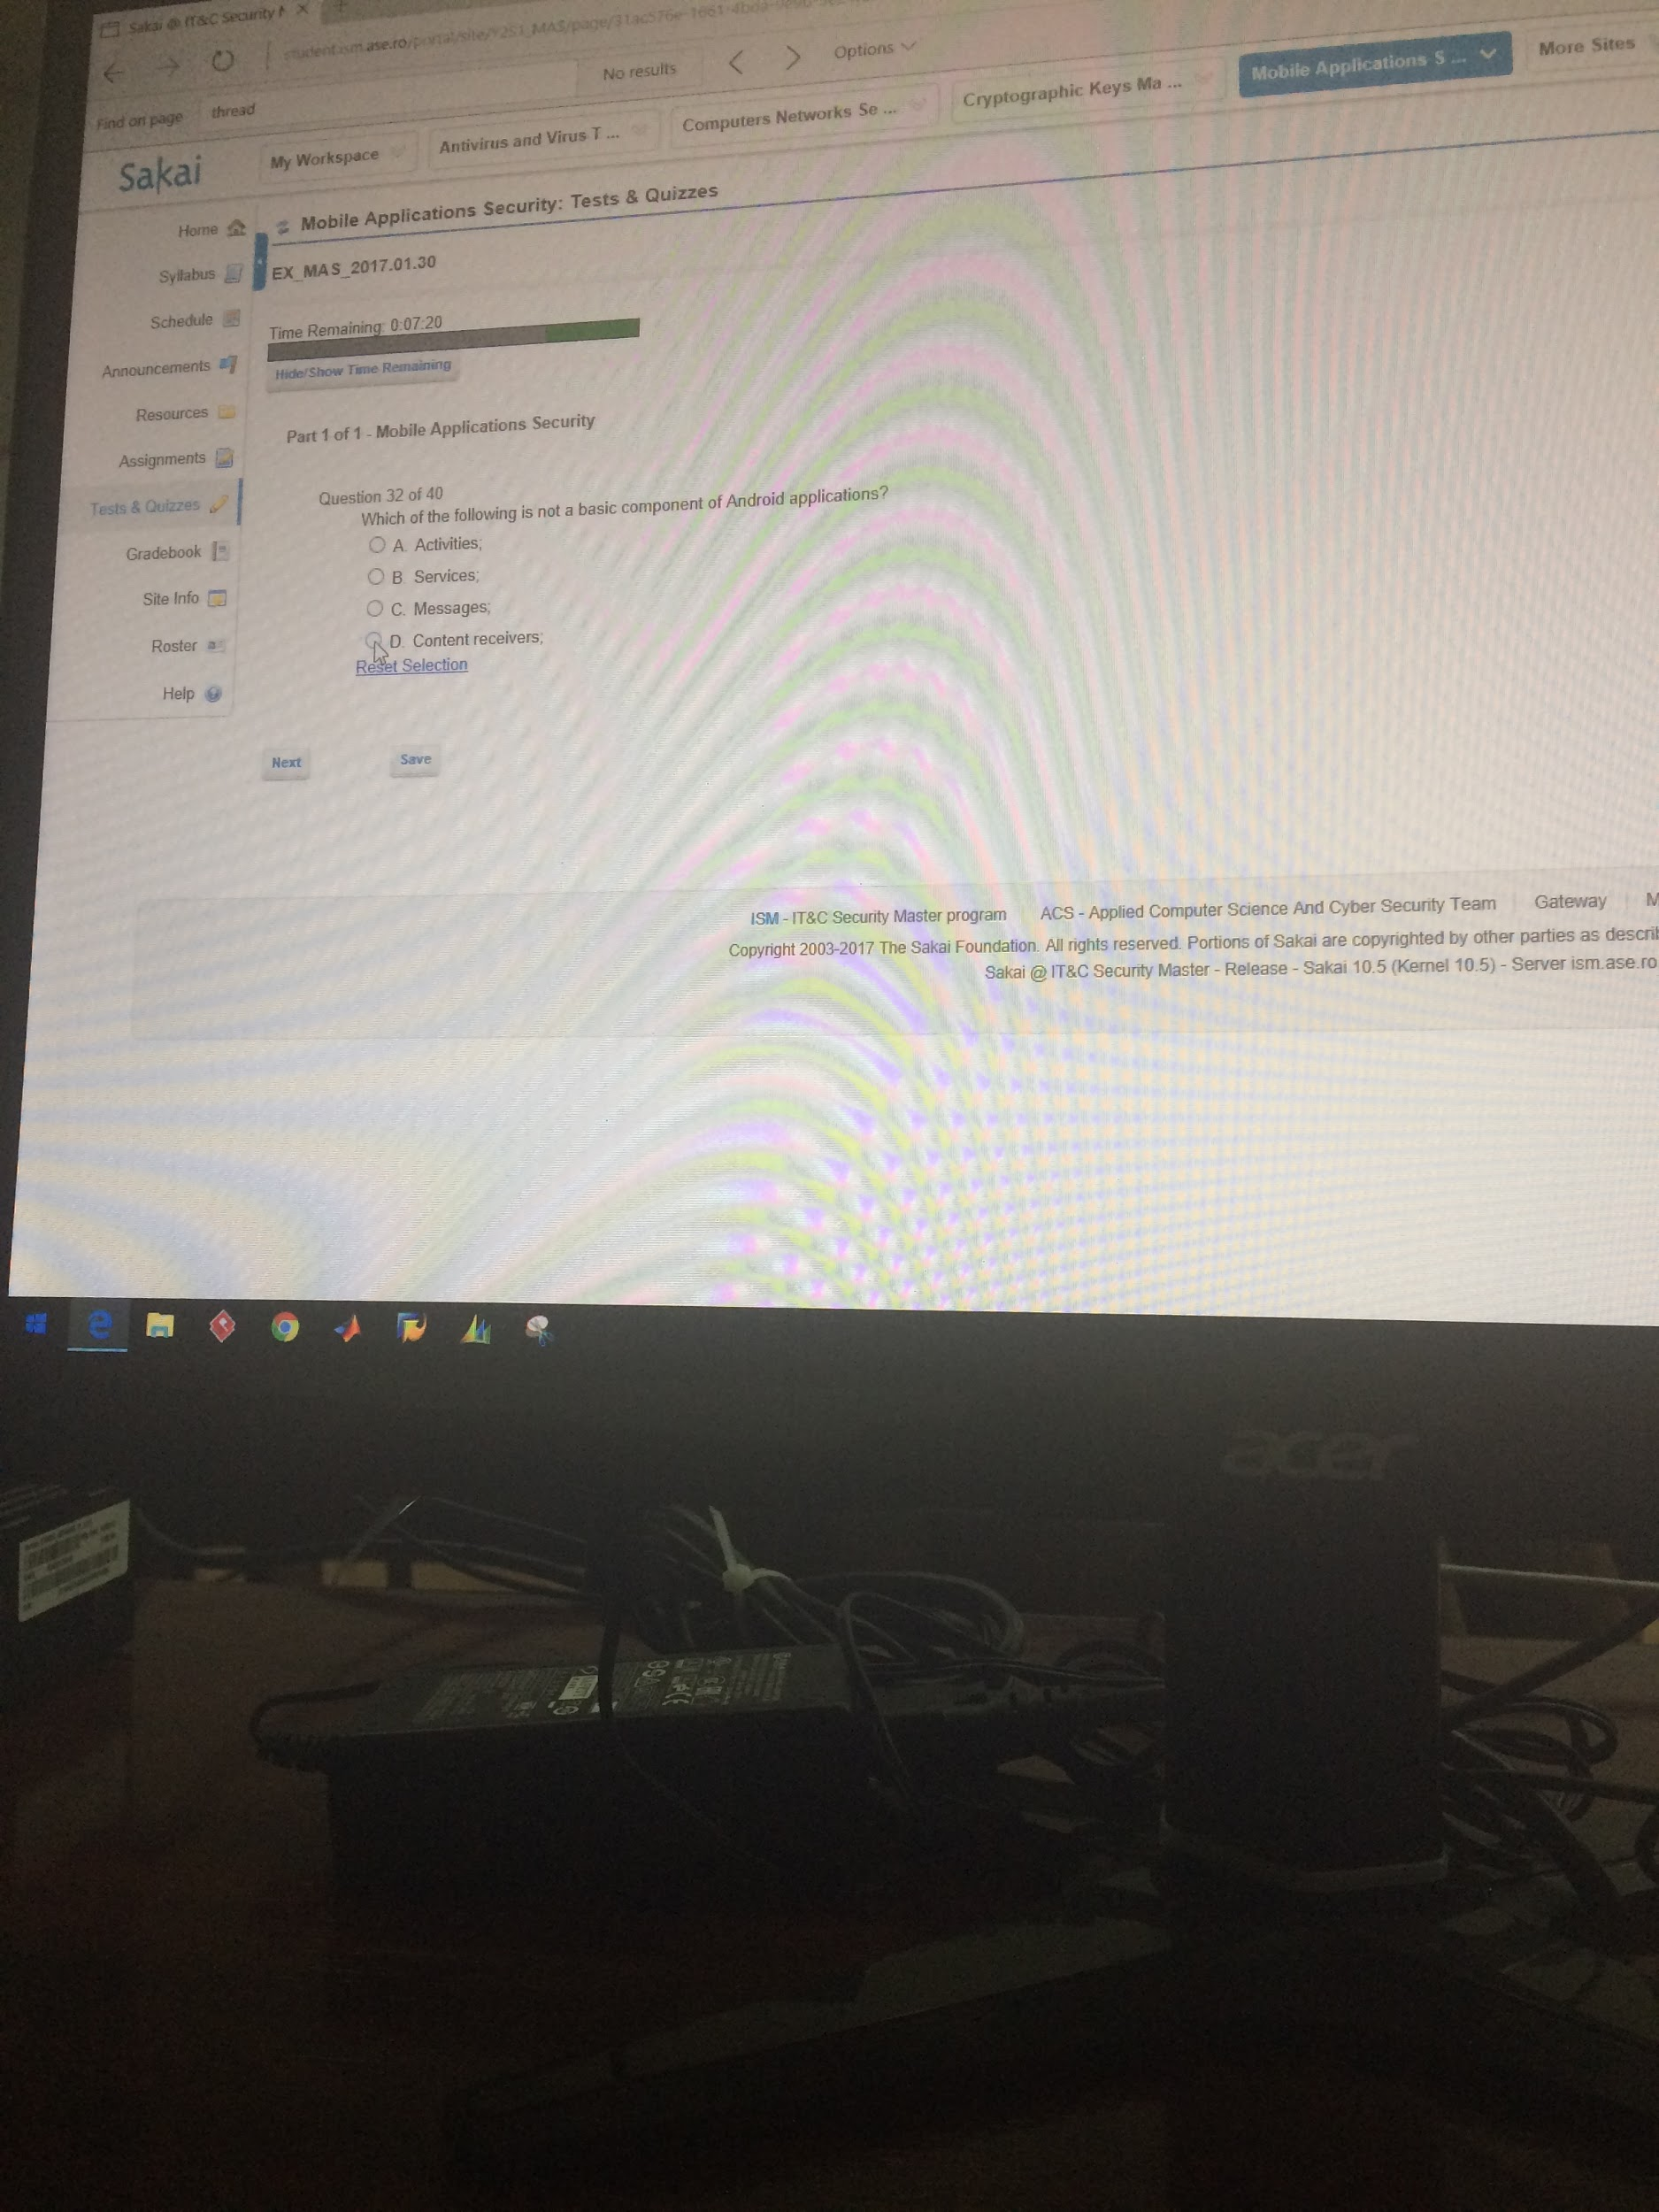

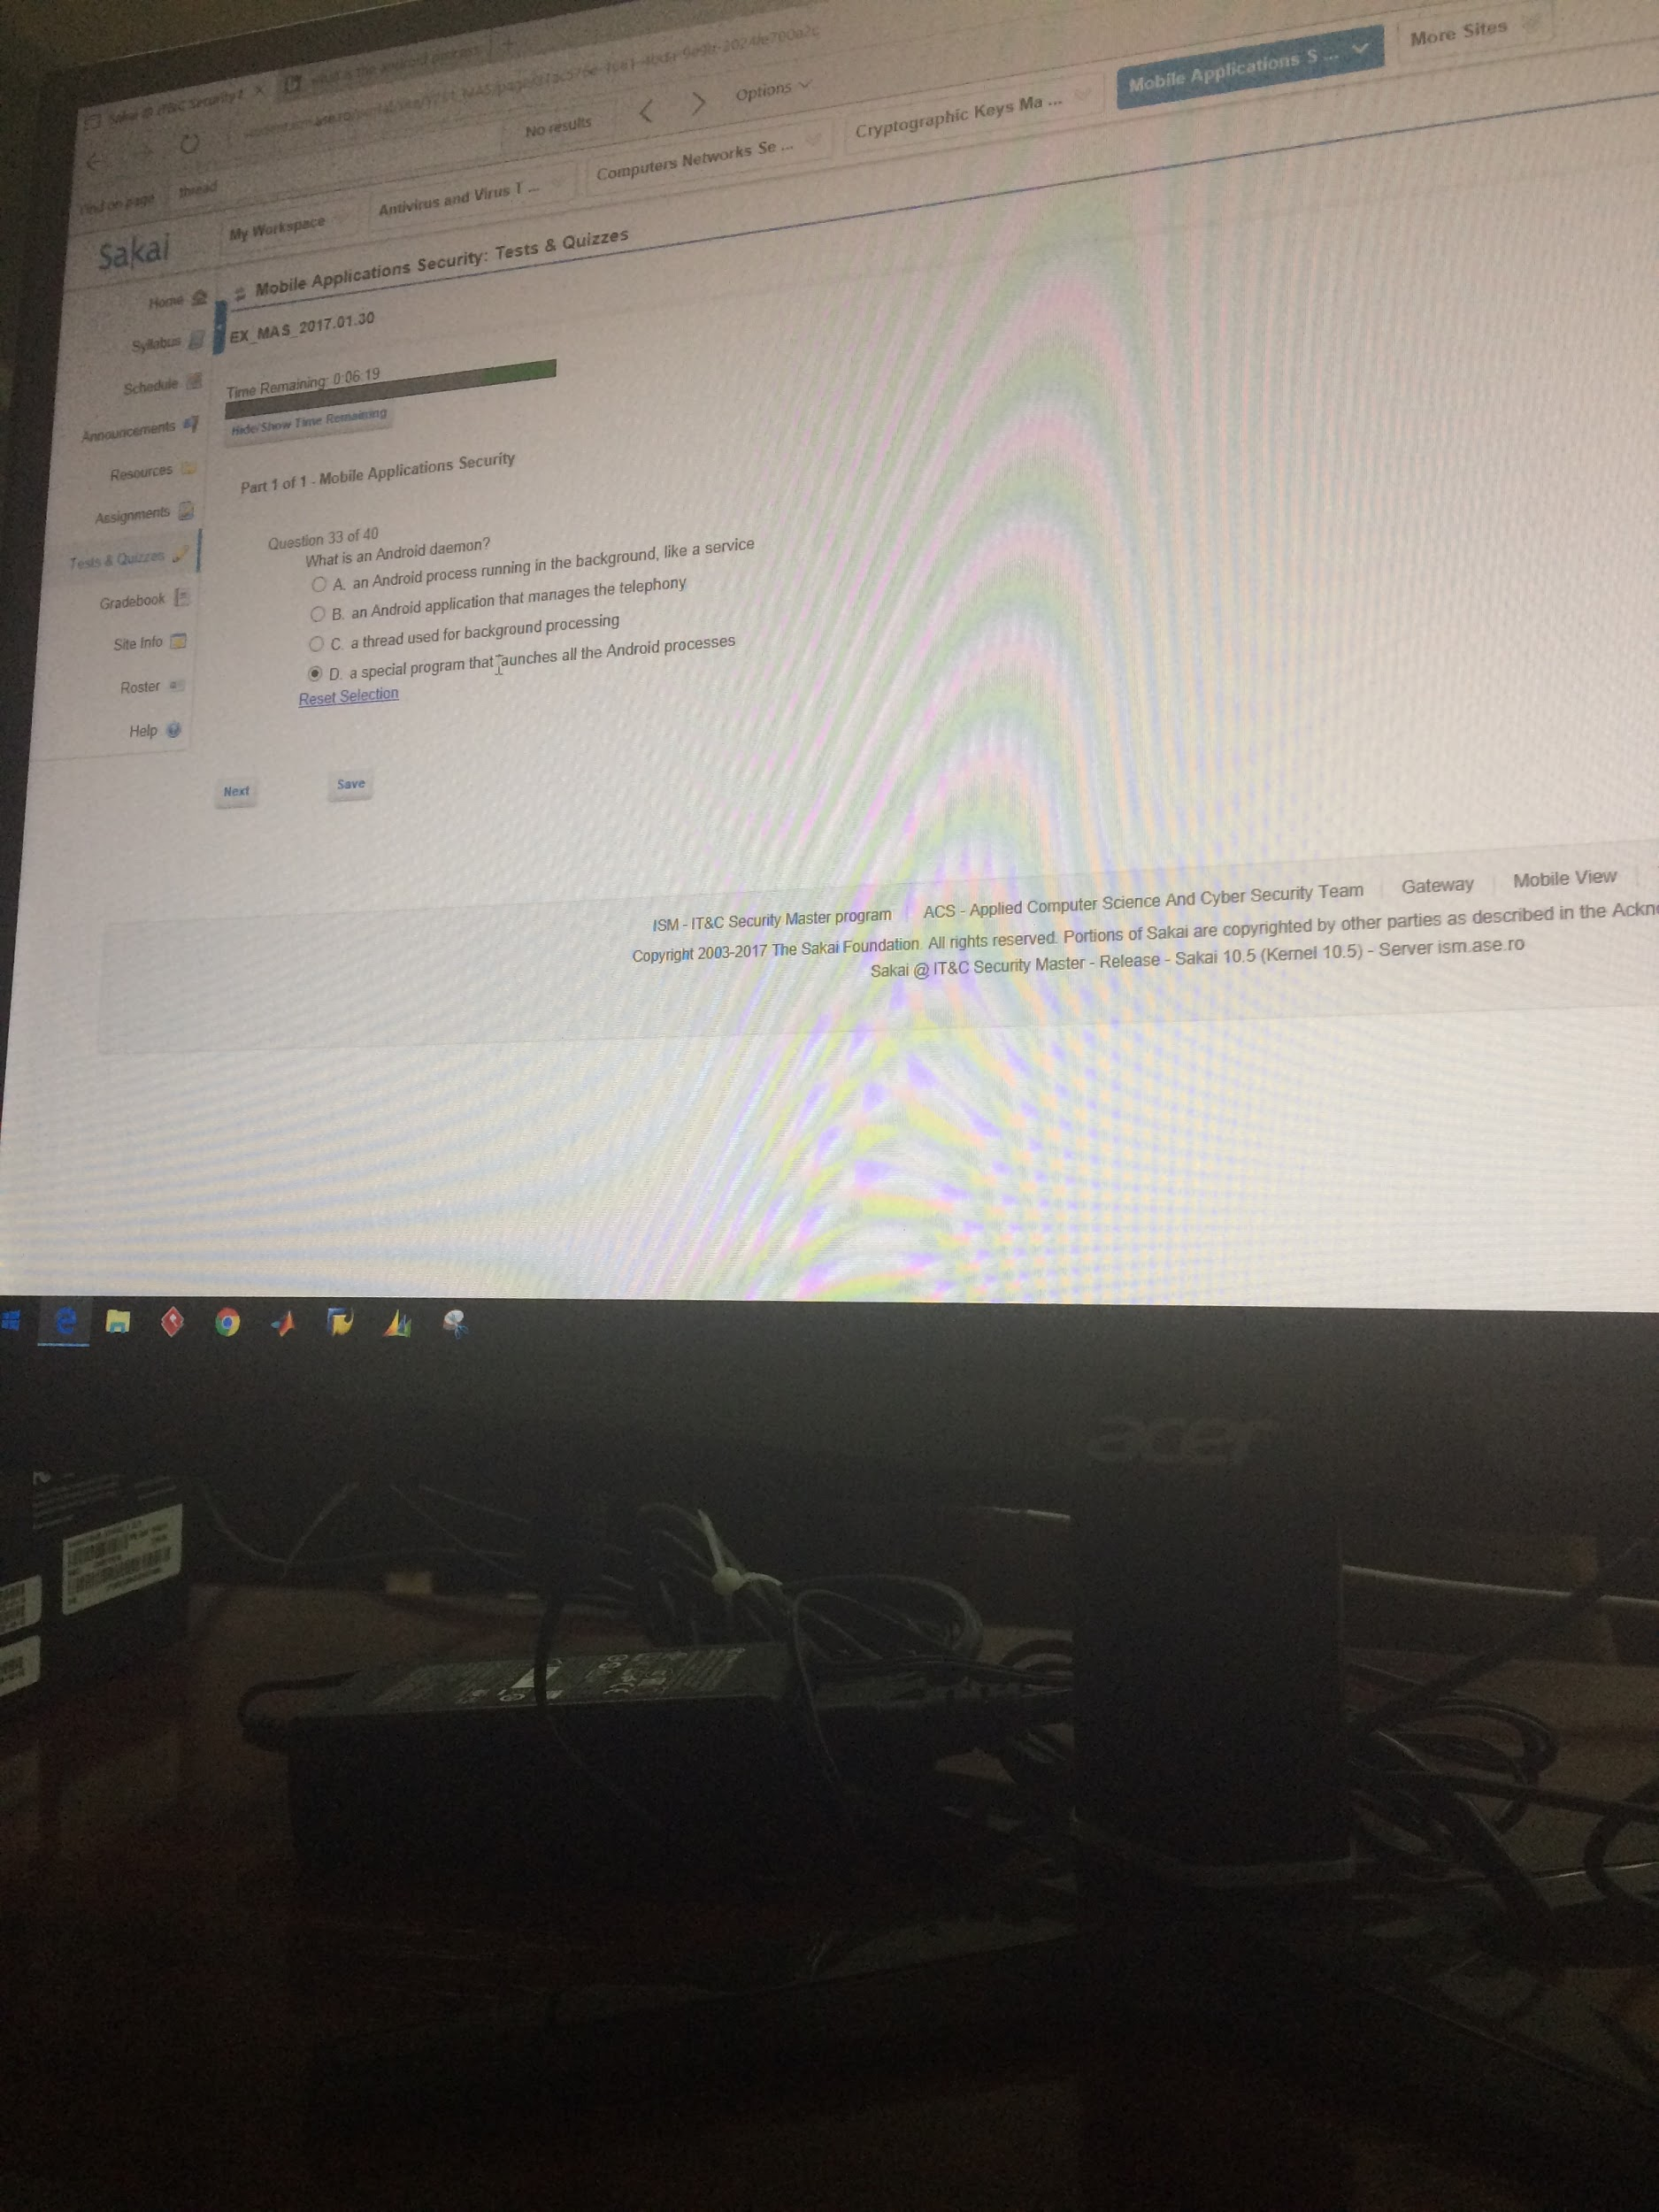

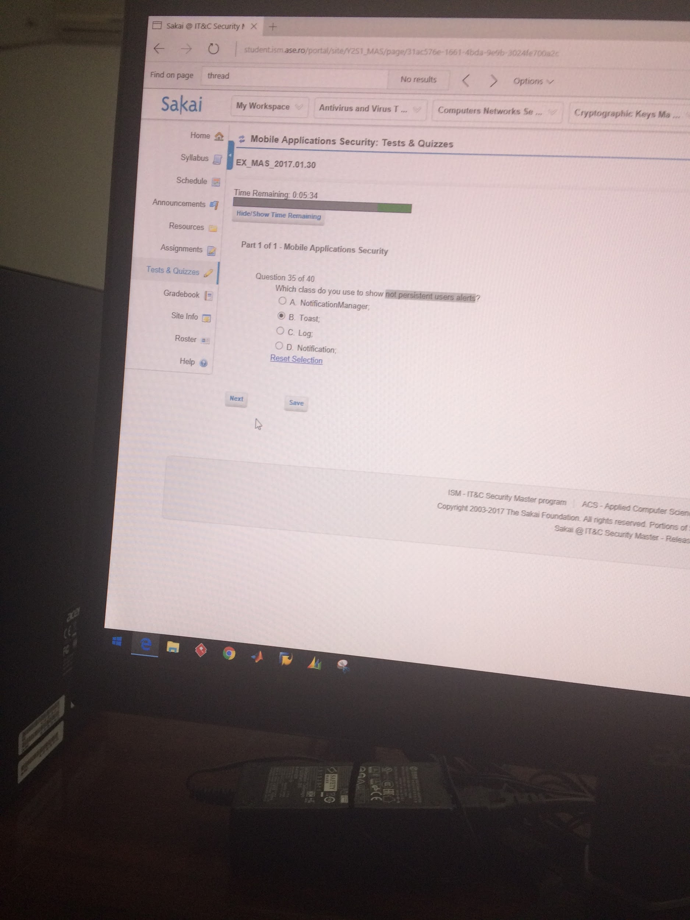

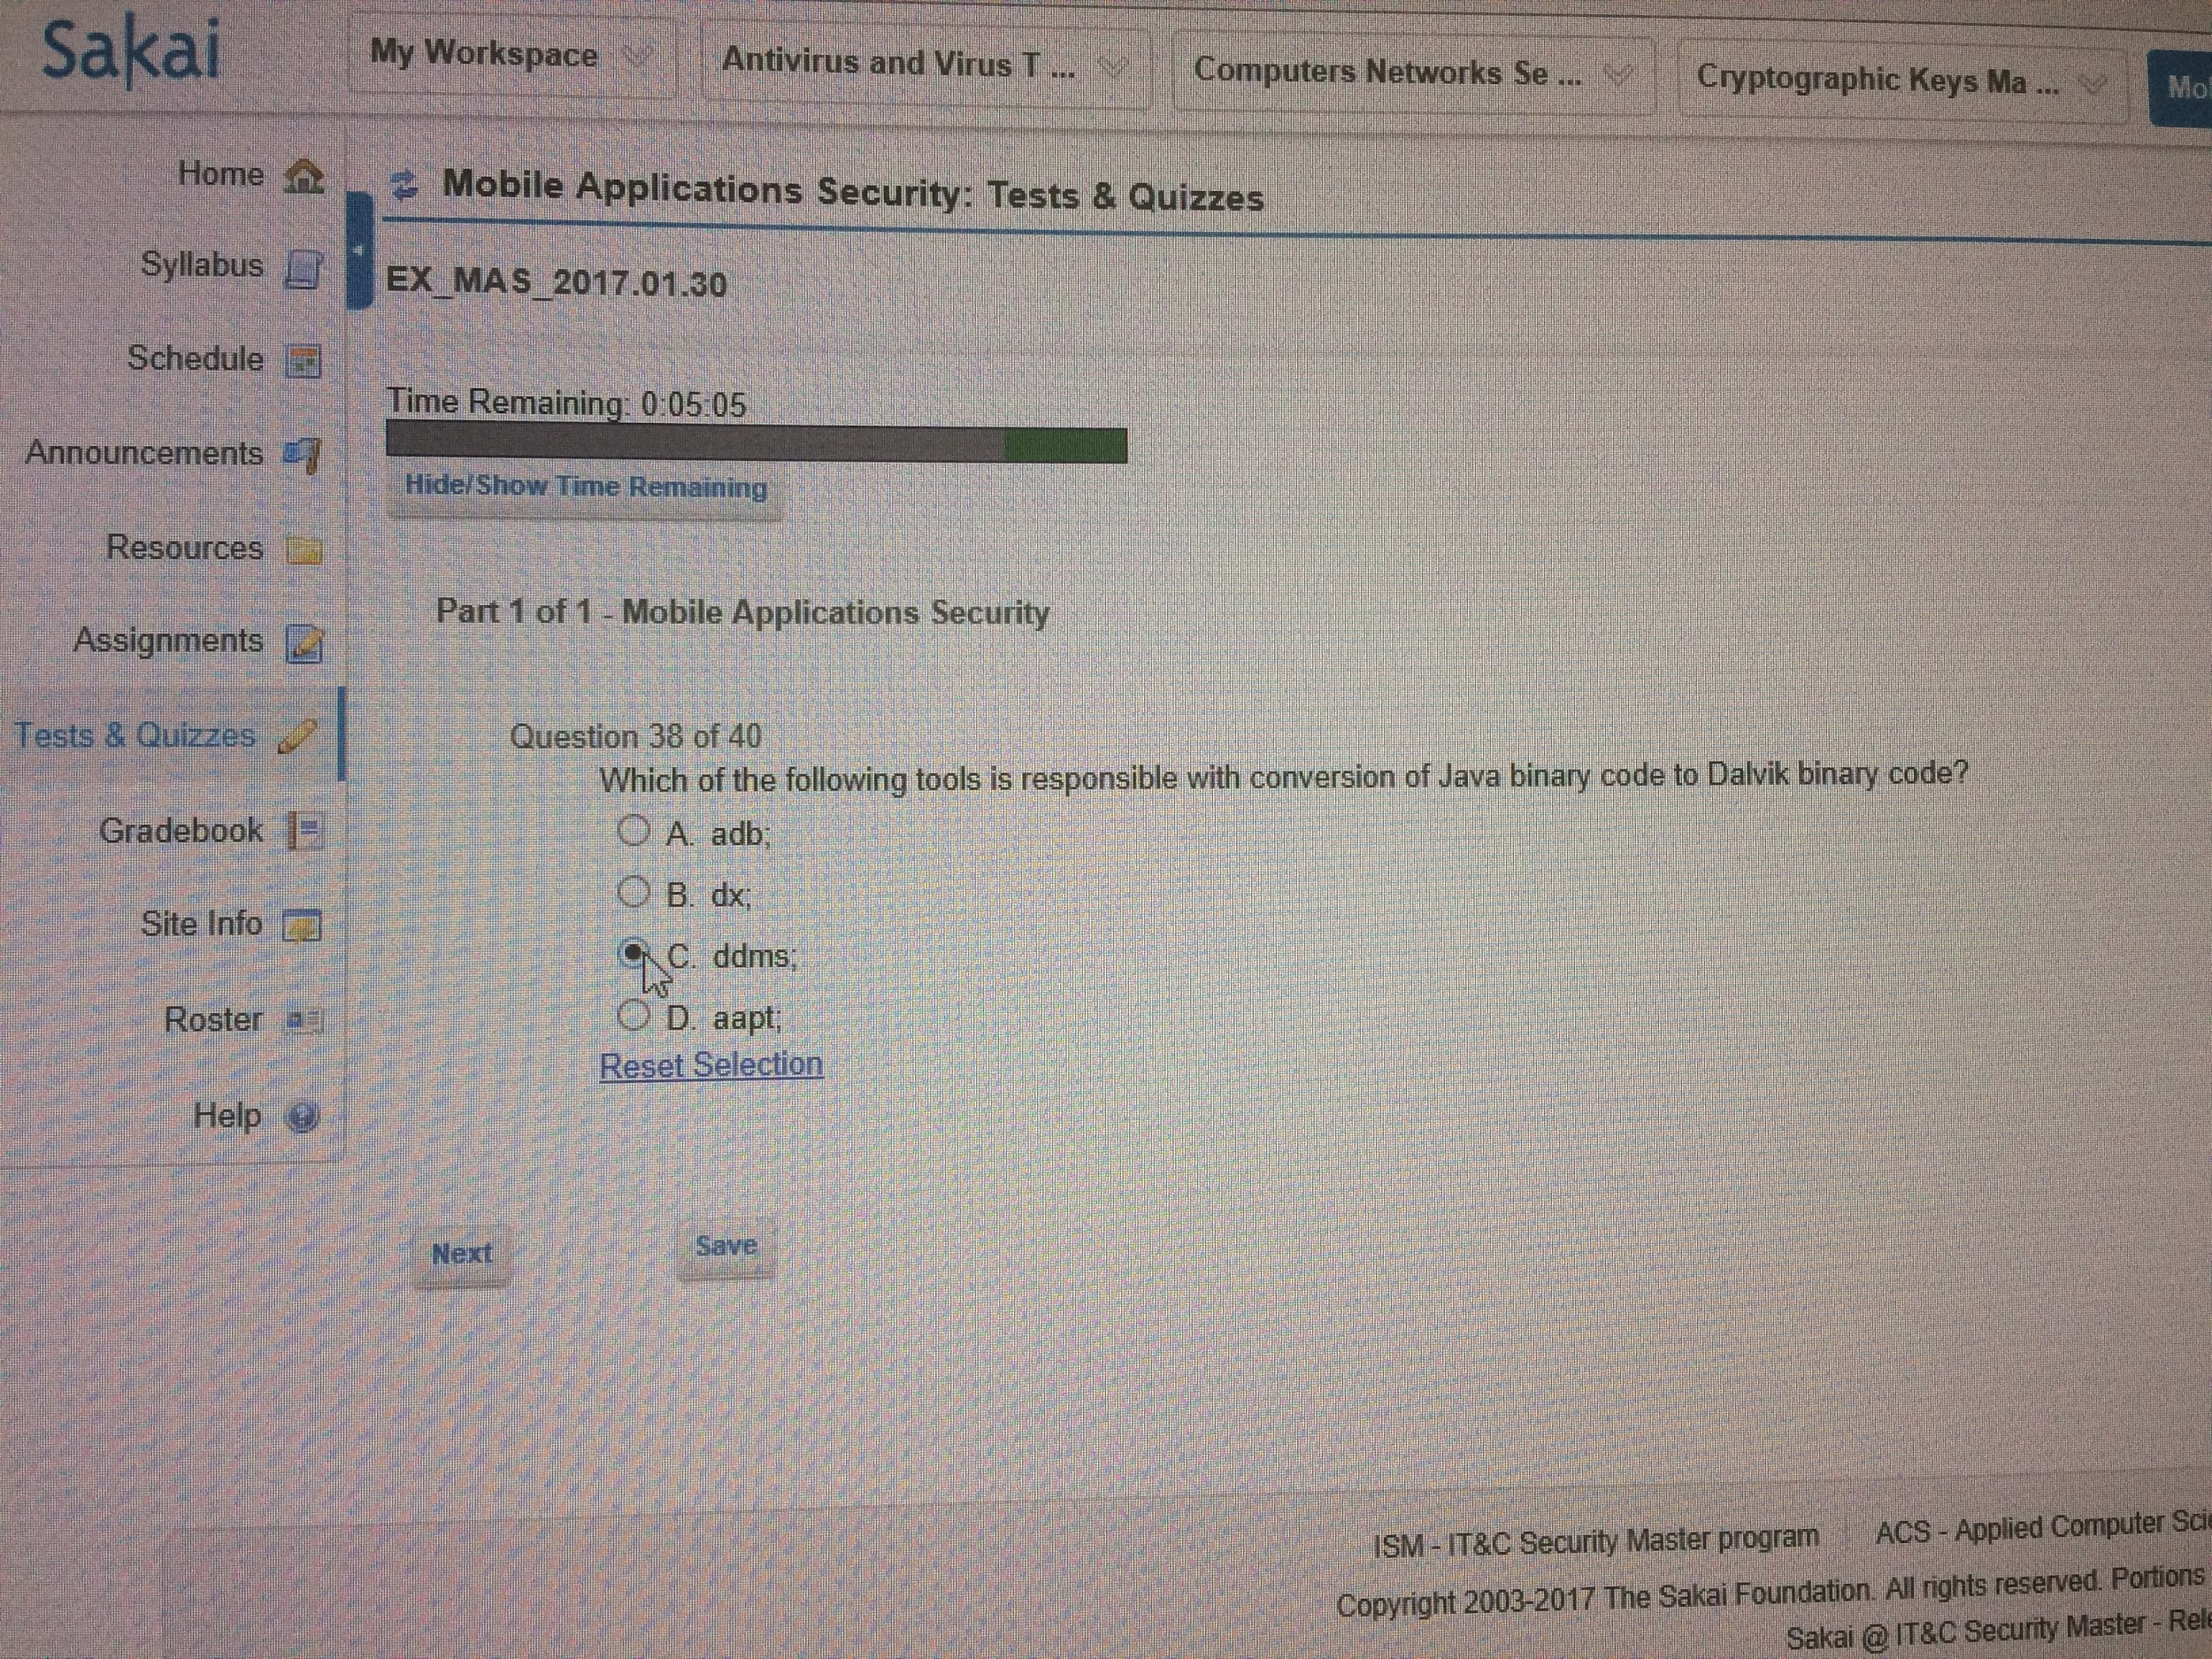

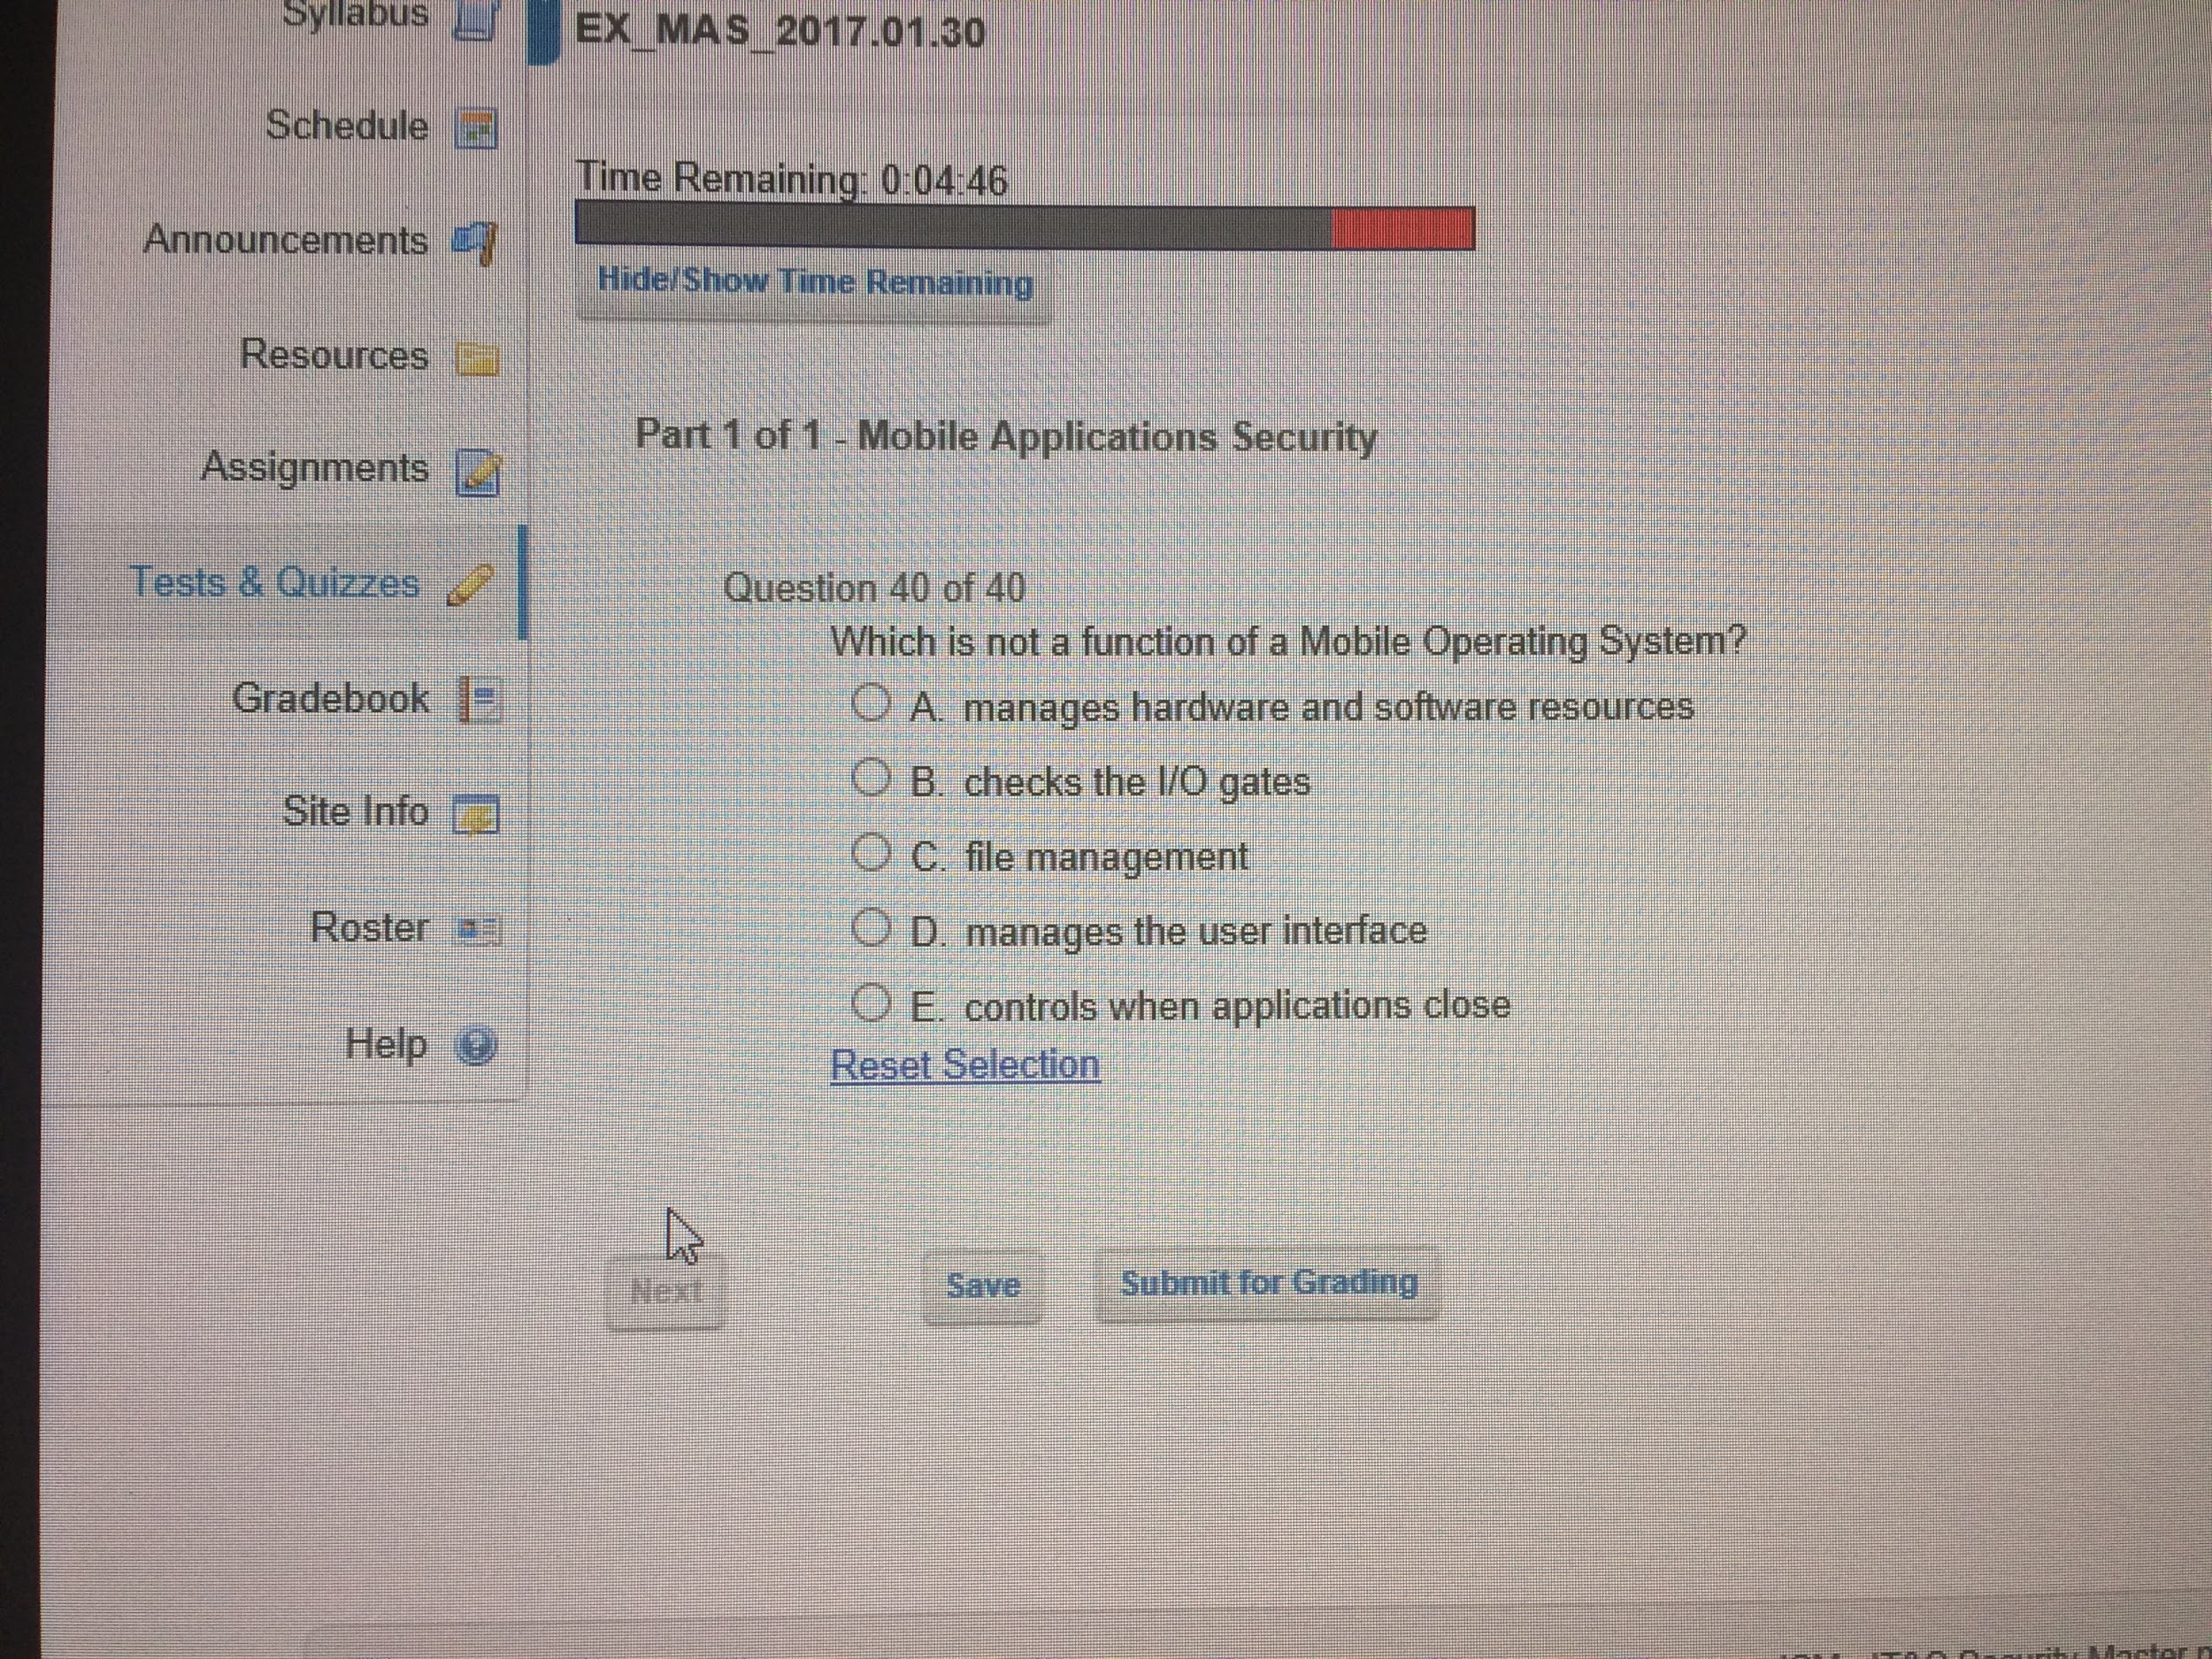

[quiz](https://www.qfeast.com/scored/quiz/Lp2xNe/Mobile-application-security?ref=sl)